**AWS BDS - STUDY-Notes**

**MOOCs**

* Linux Academy AWS BDS Course
* ACloud Guru AWS BDS Course
* Udemy AWS DBS Course
* AWS Data Architect BootCamp (General for Exam & Interview Prep)
* ACloud Guru Redshift Deep Dive
* ACloud Guru Dynamo DB Dive (Not latest but good fundamentals)
* ACloud Guru Machine Learning Specialty Exam
* Linux Academy Machine Learning Specialty Exam
* AWS Big Data Readiness – Video/ 1 Day Online Course

**Practice Tests – 65 Q/ 3 hr**

* Linux Academy Test
* Udemy Test
* AWS Practice Exams

**Kinesis**

Blogs

* <https://aws.amazon.com/blogs/big-data/implementing-efficient-and-reliable-producers-with-the-amazon-kinesis-producer-library/>
* <https://github.com/awslabs/amazon-kinesis-connectors>
* <https://aws.amazon.com/blogs/compute/amazon-kinesis-firehose-data-transformation-with-aws-lambda/>
* <https://aws.amazon.com/blogs/big-data/querying-amazon-kinesis-streams-directly-with-sql-and-spark-streaming/>
* <https://aws.amazon.com/blogs/big-data/optimizing-downstream-data-processing-with-amazon-kinesis-data-firehose-and-amazon-emr-running-apache-spark/>
* <https://read.acloud.guru/deep-dive-into-aws-kinesis-at-scale-2e131ffcfa08>
* <https://aws.amazon.com/blogs/big-data/encrypt-and-decrypt-amazon-kinesis-records-using-aws-kms/>
* <https://aws.amazon.com/blogs/big-data/under-the-hood-of-server-side-encryption-for-amazon-kinesis-streams/>

Whitepapers/Best Practices

* <https://d1.awsstatic.com/whitepapers/whitepaper-streaming-data-solutions-on-aws-with-amazon-kinesis.pdf>
* <https://d1.awsstatic.com/whitepapers/Serverless_Streaming_Architecture_Best_Practices.pdf>

Videos

* [Analyzing Data Streams in Real Time with Amazon Kinesis (BDA307)](https://www.youtube.com/watch?v=PvxlF3A-Res)
* [High Performance Data Streaming with Amazon Kinesis: Best Practices (ANT322-R1)](https://www.youtube.com/watch?v=jKPlGznbfZ0)
* [Architecting for Real-Time Insights with Amazon Kinesis (ANT310)](https://www.youtube.com/watch?v=jhYIxM2KiLs)
* [Analyzing Data Streams in Real Time with Amazon Kinesis: PNNL's Serverless Data Lake Ingestion](https://www.youtube.com/watch?v=dNp1emFFGbU&t=4s)

FAQs

* <https://aws.amazon.com/kinesis/data-streams/faqs/>
* <https://aws.amazon.com/kinesis/data-firehose/faqs/>
* <https://aws.amazon.com/sqs/faqs/>

# AWS Kinesis

* Kinesis Video Streams: build custom applications that process or analyze streaming video
* Kinesis Data Streams: build custom applications that process or analyze streaming data
* Kinesis Data Firehose: deliver real-time streaming data to AWS destinations such as S3, Redshift, Kinesis Analytics, and Elasticsearch Service
* Kinesis Data Analytics: process and analyze streaming data with standard SQL

## **AWS Kinesis Video Streams**

Three components:

* Producer: send video/audio data to one or more video streams.
  + Producer API: **PutMedia** API to write media data to a Kinesis video stream
  + In a PutMediarequest, the producer sends a stream of media fragments. A fragment is a self-contained sequence of frames.
  + As fragments arrive, Kinesis Video Streams assigns a unique fragment number, in increasing order. It also stores producer-side and server-side timestamps for each fragment, as Kinesis Video Streams-specific metadata.
* Video Stream: create a Kinesis video stream using the AWS Management Console or programmatically using the AWS SDKs.
* Consumer: create consumer applications to run on EC2 instances to get data (fragments and frames) to view, process or analyze
  + **Consumer APIs:**GetMedia – input the starting fragment, returns fragments; GetMediaFromFragmentList (and ListFragments) – Batch processing applications are considered offline consumers.

## **AWS Kinesis Data Streams**

Three components:

* Data Stream: a set of shards
  + Calculate initial number_of_shards
    - number_of_shards = max(incoming_write_bandwidth_in_KiB/1024, outgoing_read_bandwidth_in_KiB/2048)
    - incoming_write_bandwidth_in_KiB = average_data_size_in_KiB (round up to nearest 1 KiB) x records_per_second
    - outgoing_read_bandwidth_in_KiB = incoming_write_bandwidth_in_KiB x number_of_consumers
  + Each shard has a sequence of data records. Shard supports Read: 5 transactions per second, up to a maximum total data read rate of 2 MB per second. Shard support Write: up to 1,000 records per second, up to a maximum total data write rate of 1 MB per second (including partition keys)
  + Data records are composed of a sequence number, a partition key, and a data blob, which is an immutable sequence of bytes.
    - A partition key is used to group data by shard within a stream – Unicode strings (max 256 bytes, MD5 hash)
    - A sequence number is unique within its shard – cannot be used as indexes, assigned by Kinesis Data Streams
  + The retention period is set to a default of 24 hours after creation. You can increase the retention period up to 168 hours (7 days)
  + Reshard: adjust the number of shards in your stream to adapt to changes in the rate of data flow through the stream. Resharding is always pairwise (e.g. cannot split/merge into more than two shards) in a single operation
    - Shard split: increase the capacity (and cost) of your stream
    - Shard merge: reduce the cost (and capacity) of your stream
    - Reshard process: parent shard transitions from OPEN to CLOSED then EXPIRED
* Producer: put records(data ingestion) into Kinesis Data Streams
  + Automatically encrypt sensitive data as a producer enters it into a stream – uses AWS KMS master keys for encryption
  + Kinesis Agent: a stand-alone Java software application that offers an easy way to collect and send data to Kinesis Data Streams
  + Using Kinesis Data Streams API: develop producers using the Kinesis Data Streams API with the AWS SDK for Java – putRecord/putRecords
  + KPL (Kinesis Producer Library)  simplifies producer application development. Key concepts in KPL:
    - User records: blob data (e.g. JSON blob representing a UI event on a website). It is different than data records
      * Retry mechanism: user records using the KPL addUserRecord operation, a record is given a time stamp and added to a buffer with a deadline set by RecordMaxBufferedTime configuration parameter. This time stamp/deadline combination sets the buffer priority. Records are flushed from the buffer based on buffer priority, aggregation configuration, and collection configuration. Records flushed are then sent to Kinesis data stream with PutRecords operation. The operation sends requests to the stream that occasionally exhibit full or partial failures. Records that fail are automatically added back to the KPL buffer. The new deadline is set based on the minimum of these two values: half the current RecordMaxBufferedTime configuration and the record’s time-to-live value
      * Rate limiting: reduce spamming which limits per-shard throughput sent from a single producer.
    - Batching: perform a single action on multiple items. The two types of KPL batching are designed to coexist and can be turned on or off independently of one another.
      * Aggregation: store multiple records within a single Kinesis Data Streams record. Improve per shard throughput. Optimize TCO of the stream
      * Collection: use the API operation PutRecords to send multiple Kinesis Data Streams records to one or more shards in your Kinesis data stream. Reduce the overhead of making many separate HTTP requests for multi-shard stream
* Consumer: get records from Kinesis Data Streams and process them.
  + Two types of consumers: shared fan-out consumers (fixed at a total of 2 MiB/sec per shard for all consumers, 200ms, HTTP) and enhanced fan-out consumers (up to 2MiB/sec per shard per consumer, 70ms, HTTP/2)
  + KCL (Kinesis Client Library) consume and process data from a Kinesis Data Stream – instantiate a worker
  + Kinesis Data Streams application: deploy it on EC2. Utilize EC2 autoscaling
  + Use Kinesis Data Firehose to deliver the stream to S3, Redshift, Elasticsearch Service (ES), or Splunk
  + Use Kinesis Data Streams API: get data from a stream, getRecords, getShardIterator,  adapt to Reshard
  + Kinesis connector library: a pre-built library that helps you easily integrate  Kinesis Data Streams with other AWS services and third-party tools. Kinesis Client Library (KCL) is required for using this library. The current version of this library provides connectors to DynamoDB, Redshift, S3, and Elasticsearch. The library also includes sample connectors of each type, plus Apache Ant builds files for running the samples.

## **Streaming Platforms: Apache Kafka vs. AWS Kinesis**

Also Refer to :<https://blog.scottlogic.com/2018/04/17/comparing-big-data-messaging.html>

<https://blog.scottlogic.com/2018/07/06/comparing-streaming-frameworks-pt1.html>

Apache Kafka and AWS Kinesis are two real-time data streaming platforms. Both have excellent features to support the needs of businesses concerning real-time streams of data collection and analytics. But how do you choose between the two? In this article, I will compare Apache Kafka and AWS Kinesis.

## **Apache Kafka**

Apache Kafka is an open-source stream-processing software platform developed by Linkedin, donated to Apache Software Foundation, and written in Scala and Java. APIs allow producers to publish data streams to topics. A topic is a partitioned log of records with each partition being ordered and immutable. Consumers can subscribe to topics. Kafka can run on a cluster of brokers with partitions split across cluster nodes.

Kafka has five core APIs:

* The Producer API allows applications to send streams of data to topics in the Kafka cluster.
* The Consumer API allows applications to read streams of data from topics in the Kafka cluster.
* The Streams API allows transforming streams of data from input topics to output topics.
* The Connect API allows implementing connectors that continually pull from some source system or application into Kafka or push from Kafka into some sink system or application.
* The AdminClient API allows managing and inspecting topics, brokers, and other Kafka objects.

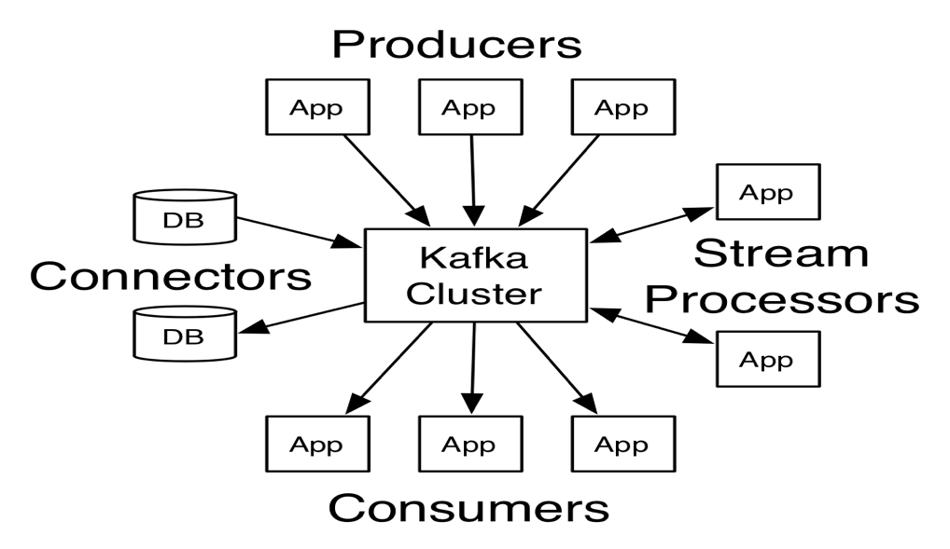

Kafka has the following feature for real-time streams of data collection and big data real-time analytics:

* Performance: Works with the huge volume of real-time data streams. Handles high throughput for both publishing and subscribing
* Scalability: Highly scales distributed systems with no downtime in all four dimensions: producers, processors, consumers, and connectors
* Fault tolerance:  Handles failures with the masters and databases with zero downtime and zero data loss
* Data Transformation: Offers provisions for deriving new data streams using the data streams from producers
* Durability: Uses Distributed commit logs to support messages persisting on disk
* Replication: Replicates the messages across the clusters to support multiple subscribers

As a result, Kafka aims to be scalable, durable, fault-tolerant, and distributed. However, Kafka requires some human support to install and manage the clusters. Also, the extra effort by the user to configure and scale according to requirements such as high availability, durability, and recovery.

## **AWS Kinesis**

[Amazon Kinesis](http://www.itcheerup.net/2019/02/kinesis_data_firehose/) has four capabilities: Kinesis Video Streams, Kinesis Data Streams, Kinesis Data Firehose, and Kinesis Data Analytics. The Kinesis Data Streams can collect and process large streams of data records in real time as same as Apache Kafka. AWS Kinesis offers key capabilities to cost-effectively process streaming data at any scale, along with the flexibility to choose the tools that best suit the requirements of your application. It enables you to process and analyze data as it arrives and responds instantly instead of having to wait until all your data is collected before the processing can begin. Let’s focus on Kinesis Data Streams(KDS).

The high-level architecture on KDS:

* The producers put records (data ingestion)  into KDS.  AWS provides Kinesis Producer Library (KPL) to simplify producer application development and to achieve high write throughput to a Kinesis data stream.
* A Kinesis data Stream a set of shards. Each shard has a sequence of data records. Data records are composed of a sequence number, a partition key, and a data blob (up to 1 MB), which is an immutable sequence of bytes.
* The consumers get records from Kinesis Data Streams and process them.  You can build your applications using either Kinesis Data Analytics, Kinesis API or Kinesis Client Library (KCL).

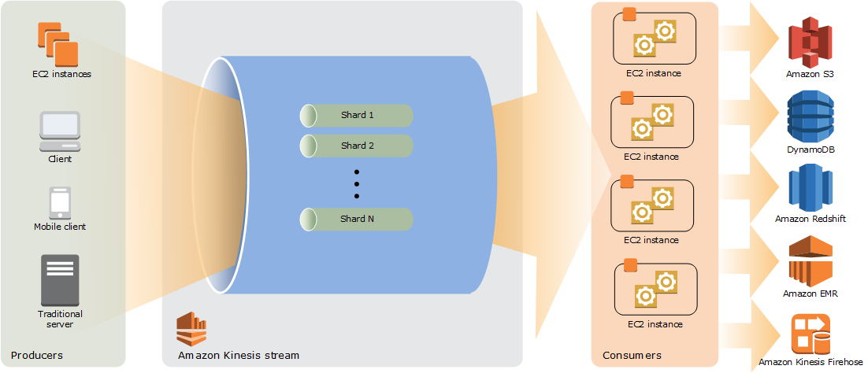

KDS has the following benefits:

* Fully managed: Kinesis is fully managed and runs your streaming applications without requiring you to manage any infrastructure
* Scalability: Handle any amount of streaming data and process data from hundreds of thousands of sources with very low latencies
* Durability: KDS application can start consuming the data from the stream almost immediately after the data is added.
* Elasticity: Scale the stream up or down, so the data records never lose before they expire
* Fault tolerance: The Kinesis Client Library enables fault-tolerant consumption of data from streams and provides scaling support for KDS applications
* Security: Data can be secured at-rest by using server-side encryption and AWS KMS master keys on sensitive data within KDS. Access data privately via your Amazon Virtual Private Cloud (VPC)

As a result, KDS is massively scalable and durable, allowing rapid and continuous data intake and aggregation; however, there is a cost for a fully managed service.  KDS has no upfront cost, and you only pay for the resources you use (e.g., $0.015 per Shard Hour.) Please check Amazon for the latest KDS [pricing](https://aws.amazon.com/kinesis/data-streams/pricing/).

## **Key Concepts Comparison**

|  |  |  |
| --- | --- | --- |
| **Concepts** | **Apache Kafka** | **AWS Kinesis Data Streams** |
| **Data Storage** | Partitions | Shards |
| **Data Ordering** | In partition level | In shard level |
| **Data Retention** | No maximum (configurable) | 1 to 7 days (default is 24 hours) |
| **Data Size Per Blob** | Default 1MB (but can be configured) | Maximum 1 MB |
| **Partition/Shard Modification** | Increase only and does not repartition existing data | Re-shard by merging or splitting shards |
| **Partition/Shard Limitation** | No limit. Optimal partitions depend on the use case | 500 shards in US East (N. Virginia), US West (Oregon), and EU (Ireland) regions. 200 shards in all other regions. |
| **Data Replication/DR** | Cluster mirroring | Automatically across 3 Availability Zones |
| **Message Delivery Semantics** | Kafka guarantees at-least-once delivery by default. Kafka supports exactly-once delivery in Kafka Streams | Kinesis Data Streams has at least once semantics |
| **Security** | Either SSL or SASL and authentication of connections to Kafka Brokers from clients; authentication of connections from brokers to ZooKeeper; data encryption with SSL/TLS | Data can be secured at-rest by using server-side encryption and AWS KMS master keys on sensitive data within KDS. Access data privately via your Amazon Virtual Private Cloud (VPC) |
| **Monitoring** | Yammer Metrics for metrics reporting in the server | AWS CloudWatch and CloudTrail |
| **Dependency** | ZooKeeper | DynamoDB |
| **Cost** | Requires a lot of human support on installation, set up, configuration and clusters management. Setup in weeks | [Pay](https://aws.amazon.com/kinesis/data-streams/pricing/) and use. Setup in a couple of hours |

## **Conclusion**

Both Apache Kafka and AWS Kinesis Data Streams are good choices for real-time data streaming platforms. If you need to keep messages for more than 7 days with no limitation on message size per blob, Apache Kafka should be your choice. However, Apache Kafka requires extra effort to set up, manage, and support.  If your organization lacks Apache Kafka experts and/or human support, then choosing a fully-managed AWS Kinesis service will let you focus on the development. AWS Kinesis is catching up in terms of overall performance regarding throughput and events processing. When moving from Apache Kafka to AWS cloud service, you can set up Apache Kafka on AWS EC2. To avoid any challenge — such as setup and scale — and to manage clusters in production, AWS offers [Managed Streaming for Kafka (MSK)](https://aws.amazon.com/msk/) with settings and configuration based on Apache Kafka’s best deployment practices.

## **AWS Kinesis Firehose**

Two components:

* Producer: send data to Kinesis Data Firehose delivery stream from Kinesis data stream, the Kinesis Agent, or the Kinesis Data Firehose API using the AWS SDK. You can also use CloudWatch Logs, CloudWatch Events, or AWS IoT as your data source
* Kinesis Data Firehose delivery stream: use Kinesis Data Firehose to create a Kinesis Data Firehose delivery stream
  + Record: as large as 1000kb
  + Buffer: Kinesis Data Firehose buffers incoming streaming data to a certain size or for a certain period of time before delivering it to destinations. The buffer size in MBs(S3 – 1MB to 128MB, ES – 1MB to 100MB) and Buffer interval is in seconds (60s – 900s)
  + Kinesis Data Firehose retries every 5 minutes until the retry duration ends. If you set the retry duration to 0 (zero) seconds, Kinesis Data Firehose does not retry upon an index request failure.
  + Record transformation: Data Firehose can invoke Lambda function to transform incoming source data and deliver the transformed data to destinations
    - Data Transformation flow:
      1. Enables Kinesis Data Firehose data transformation with buffers incoming data up to 3 MB
      2. Invokes the specified Lambda function asynchronously with each buffered batch using the AWS Lambda synchronous invocation mode
      3. The transformed data is sent from Lambda to Kinesis Data Firehose
      4. Kinesis Data Firehose sends it to the destination when the specified destination buffering size or buffering interval is reached, whichever happens first. (The Lambda synchronous invocation mode has a payload size limit of 6 MB for both the request and the response. )
    - All transformed records from Lambda must contain the following parameters, or Kinesis Data Firehose rejects them and treats that as a data transformation failure.
      1. recordId: The record ID is passed from Kinesis Data Firehose to Lambda during the invocation.
      2. result: The status of the data transformation of the record(Ok, Dropped, ProcessingFailed)
      3. data: The transformed data payload, after base64-encoding
    - Lambda blueprints:
      1. General Firehose Processing: data transformation and status model for any custom transformation logic
      2. Apache log to JSON: Parses and converts Apache log lines to JSON objects, using predefined JSON field names.
      3. Apache log to CSV: Parses and converts Apache log lines to CSV format.
      4. Syslog to CSV: Parses and converts Syslog lines to CSV format
      5. Kinesis Data Firehose Process Record Streams as the source: Accesses the Kinesis Data Streams records in the input and returns them with a processing status.
      6. Kinesis Data Firehose Cloudwatch Logs Processor: Parses and extracts individual log events from records sent by CloudWatch Logs subscription filters

# AWS Kinesis Data Streams vs. Kinesis Data Firehose

The AWS Kinesis Platform offers four services:

1. Kinesis Video Streams (which can capture, process, and store live media data)
2. Kinesis Data Streams (which can capture, process, and store real-time data)
3. Kinesis Data Firehose (which can load real-time data streams into data storage)
4. Kinesis Data Analytics (which can analyse real-time data with SQL).

AWS Kinesis Data Streams may be considered as a cloud-native service of Apache Kafka.  These three data set services — Kinesis Data Streams, Kinesis Data Firehose, and Kinesis Data Analytics — can work together to perform the real-time analysis.

## **Data Flows**

One may see different combinations of these three data set services such as:

* Input -> Kinesis Data Streams -> Kinesis Data Analytics, Spark on EMR, you consume code on EC2, or Lambda function -> Output
* Input -> Kinesis Data Firehose -> AWS S3, AWS Redshift, AWS Elasticsearch Service (ES), or Splunk -> Output
* Input -> Kinesis Data Streams or Kinesis Data Firehose -> Kinesis Data Analytics -> Output
* Input -> Kinesis Data Streams -> Kinesis Data Analytics -> Kinesis Data Firehose and/or Kinesis Data Streams -> Process or store data -> Output
* Input -> Kinesis Data Streams -> Kinesis Data Firehose -> Store data for Analytics ->Output

For example, consider the Streaming Analytics Pipeline architecture on AWS: one can either analyze the stream data through the Kinesis Data Analytics application and then deliver the analyzed data into the configured destinations or trigger the Lambda function through the Kinesis Data Firehose delivery stream to store data into S3.

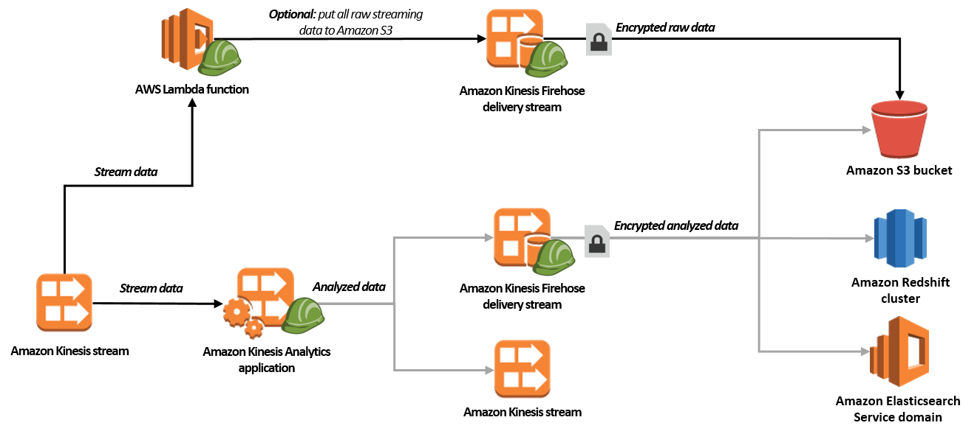

Another example mentioned in the [AWS document](https://docs.aws.amazon.com/firehose/latest/dev/writing-with-kinesis-streams.html) is that you can configure Amazon Kinesis Data Streams to send information to a Kinesis Data Firehose delivery stream. After that, you can also use Kinesis Data Analytics or other Kinesis Data Streams which depends on the use case. Concerning data streaming buffer, both Data Streams and Data Firehose can fulfil this task. Thus, in this post, we will compare Kinesis Data Streams (KDS) and Kineses Data Firehose (KDF).

## **Kinesis Data Set of Services**

Let’s take a quick look at the architectures of the three services:

### **Kinesis Data Streams**

A model of the architecture of Kinesis Data Streams is shown below:



* The producers put records (data ingestion) into KDS. AWS provides Kinesis Producer Library (KPL) to simplify producer application development and to achieve high write throughput to a Kinesis data stream.
* A Kinesis data Stream is a set of shards. Each shard has a sequence of data records. Data records are composed of a sequence number, a partition key, and a data blob (up to 1 MB), which is an immutable sequence of bytes.
* The consumers get records from Kinesis Data Streams and process them. You can build your applications using either Kinesis Data Analytics, Kinesis API or Kinesis Client Library (KCL).

### **Kinesis Data Firehose**

A model of the architecture of Kinesis Data Firehose is shown below:

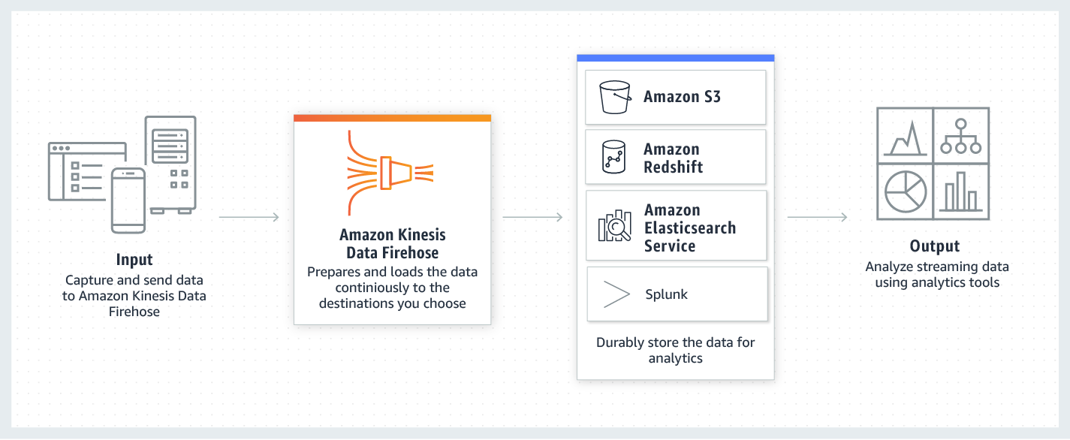

* Data producers send records to Kinesis Data Firehose delivery streams.
* The underlying entity of Kinesis Data Firehose is Kinesis Data Firehose delivery stream. It automatically delivers the data to the destination that you specified (e.g. S3, Redshift, Elasticsearch Service, or Splunk)
* You can also configure Kinesis Data Firehose to transform your data before delivering it. Enable Kinesis Data Firehose data transformation when you create your delivery stream. Then Kinesis Data Firehose invokes your Lambda function to transform incoming source data and deliver the transformed data to destinations.

### **Kinesis Data Analytics**

A model of the architecture of Kinesis Data Analytics is shown below:

* Kinesis Data Analytics applications continuously read and process streaming data from Data Streams or Data Firehose in real time. In the input configuration, you map the streaming source to an in-application input stream.
* You write application code using SQL to process the incoming streaming data and produce output. You can write SQL statements against in-application streams and reference tables. You can also write JOIN queries to combine data from both of these sources.
* Kinesis Data Analytics then writes the output to a configured destination. External destinations can be a Kinesis Data Firehose delivery stream or a Kinesis data stream. You can configure a Kinesis Data Firehose delivery stream to write results to AWS S3, Redshift, or Elasticsearch Service (ES). You can also specify a Kinesis data stream as the destination with AWS Lambda to poll the stream to your custom destination.

## **Comparison**

|  |  |  |
| --- | --- | --- |
| **Concepts** | **AWS Kinesis Data Firehose** | **AWS Kinesis Data Streams** |
| **Provision** | No pre-provision | Configure the number of shards |
| **Scale/Throughput** | No limit ~ Automatic | No limit ~ Shards |
| **Data Retention** | N/A (Up to 24 hours in case the delivery destination is unavailable. Data can be delivered to AWS S3, Redshift, Elasticsearch Service and Splunk) | 1 to 7 days (default is 24 hours) |
| **Delivery** | At least once semantics | Same |
| **Multiple Consumers** | No (Data can be delivered to AWS S3, Redshift, Elasticsearch Service and Splunk) | Yes |
| **Record/Object Size** | 1000KiB | 1MB |
| **Availability** | Three AZs | Same |
| **Security** | Data can be secured at-rest by using server-side encryption and AWS KMS master keys on sensitive data within KDS. Access data privately via your Amazon Virtual Private Cloud (VPC) | Same |
| **Monitoring** | AWS Cloudwatch, CloudTrail and Kinesis Analytics | Same |
| **Cost** | [Pay](https://aws.amazon.com/kinesis/data-firehose/pricing/) and use. | [Pay](https://aws.amazon.com/kinesis/data-streams/pricing/) and use. Setup in a couple of hours |

## **Conclusion**

AWS Kinesis Data Streams enables one to build custom applications that process or analyze streaming data for specialized needs by providing the streaming buffer needed and allowing you to write the custom code with business logic. However, with Kinesis Data Firehose, one doesn’t need to write applications or manage resources. One can configure Kinesis Data Firehose to transform data with the Lambda function. Note that one can take full advantage of the Kinesis data set services by using all three of them or combining any two of them (e.g., configuring Amazon Kinesis Data Streams to send information to a Kinesis Data Firehose delivery stream, transforming data in Kinesis Firehose, or processing the incoming streaming data with SQL on Kinesis Data Analytics).

## **AWS Kinesis Data Analytics**

Three parts of each Kinesis Data Analytics application:

* Input: The streaming source for your application – a Kinesis data stream or a Kinesis Data Firehose data delivery stream
* Application code:  A series of SQL statements that process input and produce output – SQL statements or JOIN queries
* Output:  Query results go to in-application streams – S3, Redshift, ES, or a custom destination

*Kinesis Data Analytics for Java Applications:*

* Use Java to process and analyze streaming data to perform time-series analytics, feed real-time dashboards, and create real-time metrics
* Use open-source libraries based on Flink: provisioning compute resources, parallel computation, automatic scaling, and application backups
* Types of connectors: sources (a Kinesis data stream, file, or other data source), sinks (a Kinesis data stream, Kinesis Data Firehose delivery stream, or other data destination), Asynchronous I/O (asynchronous access to a data source to enrich stream events)
* Operators: transform and aggregation

*Streaming SQL:*

* Continuous queries: A query over a stream executes continuously over streaming data
* Windowed queries:
  + Stagger windows: multiple overlapping windows
  + Tumbling windows: non-overlapping
  + Sliding windows: the window slides with time using a fixed time or rowcount interval
* Stream joins: JOIN queries to correlate data

*Error handling:*

* Reports runtime errors using an in-application error stream called error_stream
* Error_stream schema: ERROR_TIME, ERROR_LEVEL, ERROR_NAME, MESSAGE, DATA_ROWTIME

**IoT**

Blogs

* [AWS IoT Authentication](https://docs.aws.amazon.com/iot/latest/developerguide/iot-authentication.html)

WhitePapers/Best Practices

* <https://d0.awsstatic.com/whitepapers/core-tenets-of-iot1.pdf>
* <https://d1.awsstatic.com/architecture-diagrams/ArchitectureDiagrams/aws-industrial-PdM-ML-storage-RA.pdf?trk=wp_card>
* <https://d1.awsstatic.com/architecture-diagrams/ArchitectureDiagrams/aws-industrial-PdM-ML-RA.pdf?trk=wp_card>
* <https://d1.awsstatic.com/architecture-diagrams/ArchitectureDiagrams/connected-home-ML-edge_RA.pdf?trk=wp_card>

Videos

* <https://www.youtube.com/watch?v=HEQkVHxu46A>

FAQs

* <https://aws.amazon.com/iot-core/faqs/>

## **IoT**

### **IoT Virtuous Cycle**

#### **Device Software**

* Amazon FreeRTOS – IoT operating system for microcontrollers
  + Local connectivity libraries (WiFi & Ethernet)
  + cloud connectivity and security libraries
  + over-the-air updates with code signing
* AWS IoT Greengrass – Extend AWS IoT to the edge
  + Connectors: pre-built integrations with third-party services, on-premises software, and AWS services
  + Secrets Manager: securely store, access, rotate and manage secrets at the edge (local messages and triggers, local actions, data and state sync, security, local resource access, over-the-air updates, machine learning inference)
  + Hardware Security Integration: store private device keys on a hardware secure element
* AWS IoT Device SDK (run on devices), AWS IoT API (HTTP/HTTPS requests), AWS SDKs (language-specific API), AWS CLI (commands)
* AWS IoT Device Tester: Windows/Linux/Mac test automation tool for connected devices

#### **Control Services**

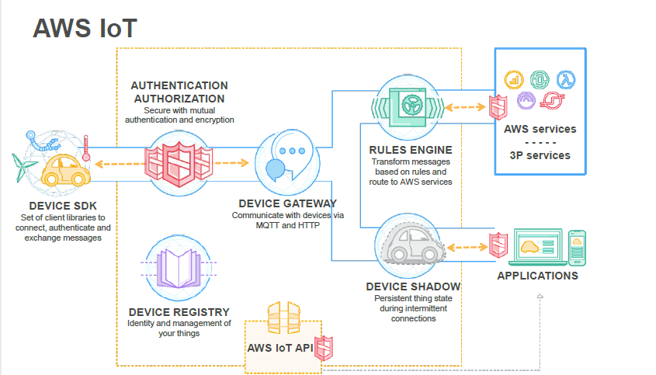

* AWS IoT Core – Secure device connectivity and messaging at scale
  + Security and identity: such as X.509 certificates, AWS IAM credentials, or 3rd party authentication via AWS Cognito. Custom authentication and authorization strategy (e.g. JSON Web Token verification, OAuth provider callout)
  + Device gateway: Allows secure, low-latency, low-overhead, bi-directional communication between connected devices and cloud and mobile applications
  + Message broker: HTTP REST interface to publish, the MQTT protocol directly or MQTT over WebSocket to publish and subscribe.
    - Three MQTT patterns: point-to-point, broadcast, and fan-in
  + Rules engine: Enables continuous processing of data sent by connected devices. Configure rules to filter and transform the data. Configure rules to route the data to other AWS services
    - Rule name, description, SQL statement(simple SQL syntax to filter messages received on an MQTT topic), SQL version, one or more actions(executing the rule e.g. write data to DynamoDB/S3/Kinesis, invoke Lambda function, publish to SNS topic), error handling action
  + Device shadow: Enables cloud and mobile applications to query data sent from devices and send commands to devices, using a simple REST API, while letting AWS IoT Core handle the underlying communication with the devices.
  + Registry: Register the devices and associate up to three custom attributes (e.g. certificates and MQTT client IDs) with each one. Also, build group registry by categorizing devices into groups.
* AWS IoT Device Management – Maintain fleet health at scale
  + Batch fleet provisioning
  + real-time fleet index & search
  + Fine-grained device logging & monitoring
  + Over-the-air updates
* AWS IoT Device Defender
  + Audit device configurations
  + Monitor device behavior
  + Identify anomalies
  + Generate alerts
  + Investigate and mitigate security issues
* AWS IoT Things Graph – Connect devices and web services with little to no code

#### **Data Services**

* AWS IoT Analytics – Run and operationalize sophisticated analytics on massive volumes of IoT data
  + Process, enrich, store, analyze, and visualizes IoT data in one service
* AWS IoT SiteWise – Collect data with the local gateway, and structure and search IoT data from industrial equipment at scale
* AWS IoT Events – Detect and respond to events from data across IoT sensors and application

## **AWS QuickSight**

* Business analytics service for visualizations and perform ad hoc analysis
  + Visuals: a graphical representation of data visualization
  + Sheets: a set of visuals that are all based on the same data source and are all viewed together
  + Stories: a set of one or more scenes (captured visuals) that you can play like a slideshow
* Discover AWS data sources and also works with your data sources
  + Data sources: local/s3 file data, Salesforce data, Athena/RDS/Redshift/external database
  + Preparing data: joining tables, using SQL query, selecting fields, using operators/functions/calculating on fields, adding filters, creating geographic hierarchies
* Robust in-memory engine – SPICE (Super-fast, Parallel, In-memory Calculation Engine) capacity:
  + Total logical row size in bytes = (Number of Numeric Fields * 8 bytes per field) + (Number of Date Fields * 8 bytes per field) + (Number of Text Fields * (8 bytes + UTF-8 encoded character length per field) )
  + Total bytes of data = Number of rows * Total logical row size in bytes
  + GB of SPICE Capacity Needed = Total bytes of data / 1,073,741,824
* QuickSight can perform typical arithmetic and comparison functions; conditional functions such as if, then; and date, numeric, and string calculations.
* QuickSight is integrated with AWS CloudTrail. This service provides a record of actions taken by a user, role, or an AWS service in QuickSight

### **Visual Types**

* Comparison and distribution
  + **Bar chart**s (horizontal or vertical) create single-measure(e.g. average delay time by flight number), multi-measure(e.g. sales total and profit total by automobile mode), or clustered bar charts (e.g. sales total by state, grouped by region).
  + Stacked bar charts similar to a clustered bar chart with color blocks
  + **Combo chart** is known as line and column charts
  + KPI visualizes a comparison between a key-value and its target value. A KPI displays a value comparison, the two values being compared, and a progress bar
* Changes over time
  + Line graphs: compare changes in measured values over a period of time
  + Area line charts: differ from regular line charts in that each value is represented by a colored area of the chart instead of just a line
* Correlation
  + Scatter plots: visualize two or three measures for a dimension
  + Heat maps: the intersection of two dimensions with color-coding
* Aggregation
  + Pie graphs: compare values for items in a dimension
  + Tree Maps: visualizes one or two measures for a dimension
* Tabular
  + Pivot tables: show measure values for the intersection of two dimensions

**Security**

* QuickSight supports multi-factor authentication (MFA)
* Private VPC (Virtual Private Cloud) Access for QuickSight uses an Elastic Network Interface (ENI) for secure
* If your VPC has been set up with public connectivity, you can add QuickSight’s IP address range to database instances’ security group rules to enable traffic flow into the VPC and database instance
* Restrict Access to a Data Set by Using Row-Level Security
  + You can do this before or after you have shared the data set.
  + Only the people you shared with can see any of the data. By adding row-level security, you can further control their access.
  + To do this, you create a query or file that has one column named UserName, GroupName, or both. You can also think of this as adding a rule for that user or group. Then you can add one column to the query or file for each field that you want to grant or restrict access to. For each user or group name that you add, you add the values for each field. You can use NULL (no value) to mean all values.

## **AWS Athena**

* An interactive query serverless service to analyze data directly in S3 using standard SQL.
* Access through AWS Management Console, through a JDBC or ODBC connection, using the Athena API, or using the Athena CLI.
* The tables creation process registers the dataset with Athena – either in the AWS Glue Data Catalog or in the internal Athena data catalog (if Glue is not available in the region).
* Analyze unstructured, semi-structured, and structured data stored in S3. Support a variety of standard data formats, including CSV, JSON, ORC, Avro, and Parquet.
* Athena also supports compressed data in Snappy, Zlib, LZO, and GZIP formats.
* Athena uses Presto to execute DML statements and Hive to execute the DDL statements that create and modify schema. Athena can handle complex analysis, including large joins, window functions, and arrays.
* Athena uses SerDes(Serializer/Deserializer) to interpret the data to read from Amazon S3.
* Partition data with PARTITIONED BY clause in the CREATE TABLE statement. To add new data from S3 into an existing table after data partitioned, you need to run a metadata query (ALTER TABLE ADD PARTITION)
* Control access: Identity and Access Management (IAM) policies, Access Control Lists (ACLs), and Amazon S3 bucket policies
* Encrypted data in S3: Server-Side Encryption with S3-Managed Encryption Keys, Server-Side Encryption with AWS Key Management Service (KMS) – Managed Keys, and Client-Side Encryption with keys managed by KMS

Use cases – Log Analysis Pipeline with S3 (Raw) – (Processed), AWS Glue and Athena

<https://aws.amazon.com/blogs/big-data/top-10-performance-tuning-tips-for-amazon-athena/>

## **AWS Glue**

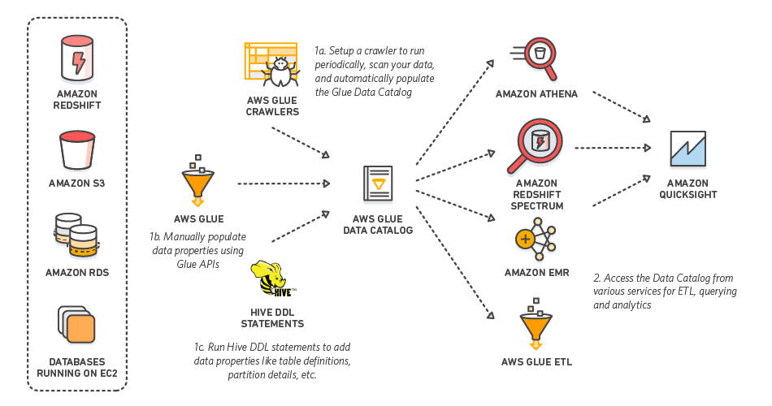

* AWS Glue is a fully managed ETL (extract, transform, and load) service
  + AWS Glue Data Catalog: central metadata repository to store structural and operational metadata. It can be used by Athena, Redshift Spectrum, EMR, and Apache Hive Metastore
  + AWS Glue Crawlers and Classifiers: scan data in all kinds of repositories, classify it, extract schema information from it, and store the metadata automatically in the AWS Glue Data Catalog
  + AWS Glue ETL Operation: autogenerate Scala or PySpark (the Python API for Apache Spark) scripts with AWS Glue extensions that you can use and modify to perform various ETL operations
  + AWS Glue Jobs system: a flexible scheduler that handles dependency resolution, job monitoring, and retries
    - ETL jobs can either be triggered on a schedule or on a job completion event.
    - Multiple jobs can be triggered in parallel or sequentially by triggering them on a job completion event.
    - You can also trigger one or more Glue jobs from an external source such as an AWS Lambda function.
    - ETL is batch-oriented with at a minimum of 5 min intervals. While it can process micro-batches, it does not handle streaming data.
    - AWS Glue allocates 10 DPUs(Data Processing Units) to each ETL job. A development endpoint is provisioned with 5 DPUs by default.
* AWS Glue natively supports data stored in RDS (Aurora/MySQL/Oracle/PostgreSQL/SQL Server), Redshift, and S3, as well as MySQL, Oracle, Microsoft SQL Server, and PostgreSQL databases in your Virtual Private Cloud (Amazon VPC) running on Amazon EC2.
* Security: server-side encryption for data at rest and SSL for data in motion
* <https://aws.amazon.com/blogs/big-data/work-with-partitioned-data-in-aws-glue/>
* <https://aws.amazon.com/blogs/big-data/extracting-salesforce-com-data-using-aws-glue-and-analyzing-with-amazon-athena/>
* <https://aws.amazon.com/blogs/big-data/our-data-lake-story-how-woot-com-built-a-serverless-data-lake-on-aws/>

**EMR**

Blogs

* <https://aws.amazon.com/blogs/big-data/analyze-your-data-on-amazon-dynamodb-with-apache-spark/>
* [Amazon EMR - Submit a Streaming Step](https://docs.aws.amazon.com/emr/latest/ReleaseGuide/CLI_CreateStreaming.html)
* [Ensuring Consistency When Using S3 and Elastic MapReduce for ETL Workflows](https://aws.amazon.com/blogs/big-data/ensuring-consistency-when-using-amazon-s3-and-amazon-elastic-mapreduce-for-etl-workflows/)
* https://aws.amazon.com/blogs/big-data/best-practices-for-running-apache-spark-applications-using-amazon-ec2-spot-instances-with-amazon-emr/
* <https://aws.amazon.com/blogs/big-data/optimize-spark-streaming-to-efficiently-process-amazon-kinesis-streams/>
* <https://aws.amazon.com/blogs/big-data/using-spark-sql-for-etl/>
* <https://aws.amazon.com/blogs/big-data/real-time-stream-processing-using-apache-spark-streaming-and-apache-kafka-on-aws/>
* <https://aws.amazon.com/blogs/big-data/migrate-rdbms-or-on-premise-data-to-emr-hive-s3-and-amazon-redshift-using-emr-sqoop/?nc1=b_rp>
* <https://aws.amazon.com/blogs/big-data/optimize-spark-streaming-to-efficiently-process-amazon-kinesis-streams/>
* <https://aws.amazon.com/blogs/big-data/modifying-your-cluster-on-the-fly-with-amazon-emr-reconfiguration/>
* <https://aws.amazon.com/blogs/big-data/powering-amazon-redshift-analytics-with-apache-spark-and-amazon-machine-learning/>
* <https://aws.amazon.com/blogs/big-data/analyze-realtime-data-from-amazon-kinesis-streams-using-zeppelin-and-spark-streaming/>
* <https://aws.amazon.com/blogs/big-data/analyze-your-data-on-amazon-dynamodb-with-apache-spark/>
* <https://aws.amazon.com/blogs/big-data/best-practices-for-securing-amazon-emr/>
* <https://aws.amazon.com/blogs/big-data/best-practices-for-resizing-and-automatic-scaling-in-amazon-emr/>
* <https://aws.amazon.com/blogs/big-data/implementing-authorization-and-auditing-using-apache-ranger-on-amazon-emr/>
* <https://aws.amazon.com/blogs/big-data/secure-amazon-emr-with-encryption/>
* <https://aws.amazon.com/blogs/big-data/migrate-and-deploy-your-apache-hive-metastore-on-amazon-emr/>

WhitePapers/Best Practices

* <https://d1.awsstatic.com/whitepapers/amazon_emr_migration_guide.pdf?trk=wp_card>
* <https://d1.awsstatic.com/whitepapers/Migrating_to_Apache_Hbase_on_Amazon_S3_on_Amazon_EMR.pdf?trk=wp_card>
* <https://d1.awsstatic.com/whitepapers/lambda-architecure-on-for-batch-aws.pdf?trk=wp_card>
* <https://d1.awsstatic.com/whitepapers/Storage/data-lake-on-aws.pdf?trk=wp_card>

FAQs

* <https://aws.amazon.com/emr/faqs/>

Videos

* <https://www.youtube.com/watch?v=5DGXPcVKXyw>
* [A Deep Dive into What's New with Amazon EMR](https://www.youtube.com/watch?v=ISl9sTzxoSo)
* [Big Data Analytics Architectural Patterns & Best Practices](https://www.youtube.com/watch?v=ovPheIbY7U8)
* [Netflix Uses Kinesis Streams to Monitor Applications and Analyze Billions of Traffic Flows](https://www.youtube.com/watch?v=8tsIqfvizpU)

## **AWS EMR**

### **Storage and File Systems**

* HDFS: prefix with hdfs://(or no prefix). HDFS is a distributed, scalable, and portable file system for Hadoop. An advantage of HDFS is data awareness between the Hadoop cluster nodes managing the clusters and the Hadoop cluster nodes managing the individual steps. HDFS is used by the master and core nodes. One advantage is that it’s fast; a disadvantage is that its ephemeral storage which is reclaimed when the cluster ends. It’s best used for caching the results produced by intermediate job-flow steps.
* EMRFS: prefix with s3:// EMRFS is an implementation of the Hadoop file system used for reading and writing regular files from Amazon EMR directly to Amazon S3. EMRFS provides the convenience of storing persistent data in S3 for use with Hadoop while also providing features like S3 server-side encryption, read-after-write consistency, and list consistency.
* Local file system: The local file system refers to a locally connected disk. When a Hadoop cluster is created, each node is created from an EC2 instance that comes with a preconfigured block of preattached disk storage called an instance store. Data on instance store volumes persists only during the life of its EC2 instance. Instance store volumes are ideal for storing temporary data that is continually changing, such as buffers, caches, scratch data, and other temporary content.

### **Node Types in Cluster**

Cluster: a collection of EC2 instances. Each instance in the cluster is called a node. The node has the following types:

* **Master node**: A node that manages the cluster by running software components to coordinate the distribution of data and tasks among other nodes for processing. The master node tracks the status of tasks and monitors the health of the cluster. Every cluster has a master node, and it’s possible to create a single-node cluster with only the master node.
* **Core node**: A node with software components that run tasks and store data in the Hadoop Distributed File System (HDFS) on your cluster. Multi-node clusters have at least one core node.
* **Task node**: A node with software components that only runs tasks and does not store data in HDFS. Task nodes are optional.

### **Hadoop Ecosystem on EMR**

* HUE – graphic user interface acts as front end application on EMR cluster to interact with other applications on EMR
* Flink – a streaming dataflow engine that you can use to run real-time stream processing on high-throughput data sources
* Phoenix – use standard SQL queries and JDBC APIs to work with an Apache HBase backing store for OLTP and operational analytics
* Presto – a fast SQL query engine designed for interactive analytic queries over large datasets from multiple sources
* Pig – use SQL-like (Pig Latin) commands that runs on top of Hadoop to transform large data sets without having to write complex code and converts those commands into Tez jobs based on directed acyclic graphs (DAGs) or MapReduce programs
* Tez – create a complex directed acyclic graph (DAG) of tasks for processing data
* Hive – use an SQL-like language called Hive QL (query language) that abstracts programming models and supports typical data warehouse interactions
* HBase – run on top of HDFS to provide non-relational database capabilities
* HCatalog**–**access Hive metastore tables within Pig, Spark SQL, and/or custom MapReduce applications. HCatalog has a REST interface and command line client that allows you to create tables or do other operations
* Zookeeper – a centralized service for maintaining configuration information, naming, providing distributed synchronization, and providing group services
* Jupyter Notebook -create and share documents that contain live code, equations, visualizations, and narrative text. Two options to work with Jupyter notebooks: EMR Notebook, JupyterHub
* Ganglia – monitor clusters and grids while minimizing the impact on their performance
* Livy – enables interaction over a REST interface with an EMR cluster running Spark
* Spark – a powerful open-source unified analytics engine with micro-batching but can guarantee only-once-delivery if configured. Four modules: MLlib, SparkSQL, Spark Streaming, and GraphX. Don’t use it for batch processing or multi-user reporting with many concurrent requests.
* Mahout – a machine learning library with tools for clustering, classification, and several types of recommenders, including tools to calculate most-similar items or build item recommendations for users
* MXNet – an acceleration library designed for building neural networks and other deep learning applications
* TensorFlow – an open-source symbolic math library for machine intelligence and deep learning applications
* Oozie – manage and coordinate Hadoop jobs
* Sqoop – a tool for transferring data between Amazon S3, Hadoop, HDFS, and RDBMS databases

### **Security**

* IAM
  + IAM policies allow or deny permissions for IAM users and groups
  + IAM roles for EMRFS requests to Amazon S3
  + EMR service role, instance profile, and service-linked role to access other AWS services
* Data encryption
  + Data at rest
    - For EMRFS on S3 – server-side (SSE-S3, SSE-KMS) or client-side (CSE-KMS, CSE-C) encryption
    - For local disk (cluster nodes EC2 instance store volumes attached EBS) – open-source HDFS encryption and Linux Unified Key System (LUKS) encryption
  + Data in transit
    - Between S3 and cluster nodes – TLS
    - Open source encryption –
      * Hadoop MapReduce Encrypted Shuffle uses TLS, SASL (secure Hadoop RPC set to privacy), AES256 (HDFS data block data transfer)
      * HBase: when Kerberos is enabled, the hbase.rpc.protection property is set to privacy for encrypted communication
      * Presto: SSL/TLS
      * Tez: TLS
      * Spark: AES-256 cipher for internal RPC communication between Spark components, SSL for HTTP protocol communication with user interfaces

**Lambda in the AWS Big Data Ecosystem**

Blogs

* <https://aws.amazon.com/blogs/compute/ad-hoc-big-data-processing-made-simple-with-serverless-mapreduce/>
* <https://aws.amazon.com/blogs/big-data/a-zero-administration-amazon-redshift-database-loader/>
* <https://aws.amazon.com/blogs/big-data/using-aws-lambda-for-event-driven-data-processing-pipelines/>
* <http://docs.aws.amazon.com/lambda/latest/dg/with-ddb.html>
* <https://aws.amazon.com/blogs/compute/amazon-kinesis-firehose-data-transformation-with-aws-lambda/>
* <http://docs.aws.amazon.com/lambda/latest/dg/with-kinesis.html>
* <https://aws.amazon.com/blogs/compute/implementing-a-serverless-aws-iot-backend-with-aws-lambda-and-amazon-dynamodb/>
* <https://aws.amazon.com/blogs/database/indexing-metadata-in-amazon-elasticsearch-service-using-aws-lambda-and-python/>

WhitePapers/Best Practices

* <https://d1.awsstatic.com/whitepapers/serverless-architectures-with-aws-lambda.pdf?trk=wp_card>

Videos

**REDSHIFT**

Blogs

* <https://aws.amazon.com/blogs/big-data/building-securing-and-managing-data-lakes-with-aws-lake-formation/>
* <https://aws.amazon.com/blogs/big-data/amazon-redshift-engineerings-advanced-table-design-playbook-preamble-prerequisites-and-prioritization/>
* <https://aws.amazon.com/blogs/big-data/optimizing-for-star-schemas-and-interleaved-sorting-on-amazon-redshift/>
* <https://aws.amazon.com/blogs/big-data/top-10-performance-tuning-techniques-for-amazon-redshift/>
* <https://docs.aws.amazon.com/redshift/latest/mgmt/working-with-clusters.html#rs-about-clusters-and-nodes>
* <https://docs.aws.amazon.com/redshift/latest/dg/c_designing-tables-best-practices.html>
* <https://docs.aws.amazon.com/redshift/latest/dg/c_designing-queries-best-practices.html>
* <https://docs.aws.amazon.com/redshift/latest/dg/c_data_redistribution.html>
* <https://docs.aws.amazon.com/redshift/latest/dg/c_loading-data-best-practices.html>
* <https://docs.aws.amazon.com/redshift/latest/dg/c-query-performance.html>
* <https://docs.aws.amazon.com/redshift/latest/mgmt/working-with-clusters.html>
* <http://docs.aws.amazon.com/redshift/latest/dg/t_unloading_encrypted_files.html>
* http://docs.aws.amazon.com/redshift/latest/dg/c_loading-encrypted-files.html
* [Top 8 Best Practices for High-Performance ETL Processing Using Amazon Redshift](https://aws.amazon.com/blogs/big-data/top-8-best-practices-for-high-performance-etl-processing-using-amazon-redshift/)
* [Redshift Engineering’s Advanced Table Design Playbook](https://aws.amazon.com/blogs/big-data/amazon-redshift-engineerings-advanced-table-design-playbook-preamble-prerequisites-and-prioritization/)
* [Redshift: Choosing the best Distribution model](https://docs.aws.amazon.com/redshift/latest/dg/c_best-practices-best-dist-key.html)
* [Redshift - Choosing the Best Sort Key](https://docs.aws.amazon.com/redshift/latest/dg/c_best-practices-sort-key.html)
* [Redshift: Vacuuming Tables](https://docs.aws.amazon.com/redshift/latest/dg/t_Reclaiming_storage_space202.html)
* <https://github.com/awslabs/amazon-redshift-utils/tree/master/src/AnalyzeVacuumUtility>
* <https://docs.aws.amazon.com/redshift/latest/dg/performing-a-deep-copy.html>
* <https://docs.aws.amazon.com/redshift/latest/dg/t_updating-inserting-using-staging-tables-.html>
* <https://aws.amazon.com/blogs/big-data/analyzing-apache-parquet-optimized-data-using-amazon-kinesis-data-firehose-amazon-athena-and-amazon-redshift/>
* <https://github.com/awslabs/amazon-redshift-utils/tree/master/src/SnapshotManager>
* <https://github.com/awslabs/amazon-redshift-monitoring>
* <https://www.blendo.co/amazon-redshift-guide-data-analyst/>
* <https://mixpanel.com/blog/2019/04/24/why-youre-better-off-exporting-your-data-to-redshift-spectrum-instead-of-redshift/>
* <https://aws.amazon.com/getting-started/projects/migrate-oracle-to-amazon-redshift/>

**REDSHIFT SPECTRUM**

* <https://aws.amazon.com/blogs/big-data/from-data-lake-to-data-warehouse-enhancing-customer-360-with-amazon-redshift-spectrum/>
* <https://aws.amazon.com/blogs/big-data/10-best-practices-for-amazon-redshift-spectrum/>
* <https://www.kpipartners.com/blog/advantages-of-using-redshift-spectrum>
* <https://aws.amazon.com/blogs/big-data/amazon-redshift-spectrum-extends-data-warehousing-out-to-exabytes-no-loading-required/>

WhitePapers/Best Practices

* <https://d1.awsstatic.com/whitepapers/Size-Cloud-Data-Warehouse-on-AWS.pdf?trk=wp_card>
* <https://d1.awsstatic.com/whitepapers/enterprise-data-warehousing-on-aws.pdf?trk=wp_card>

Videos

[Deep Dive on Amazon Redshift](https://www.youtube.com/watch?time_continue=36&v=Hur-p3kGDTA)

[Deep Dive & Best Practices - ReInvent 2018](https://www.youtube.com/watch?v=TJDtQom7SAA)

[Best Practices for Migrating Legacy Data Warehouses into Amazon Redshift](https://www.youtube.com/watch?v=Q4VgB_KuDNo&t=8s)

[Modern Cloud Data Warehousing (Intuit): Optimize Analytics Practices](https://www.youtube.com/watch?v=owJ-ipdTbko)

## **AWS Redshift**

* Fast, fully managed the data warehouse
  + PostgreSQL, Columnar storage engine, Massively Parallel Processing(MPP), OLAP functions
  + Wrapped with other AWS services: S3, KMS, IAM, VPC, SWF, CloudWatch
* Analyze data with standard SQL and existing BI tools

### **Architecture**

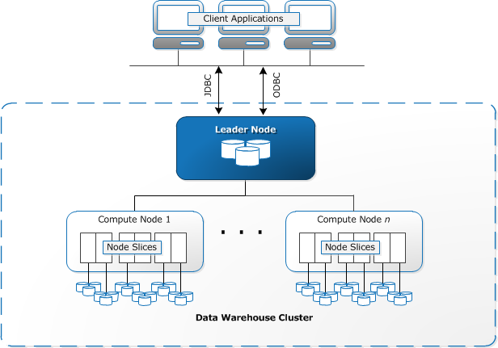

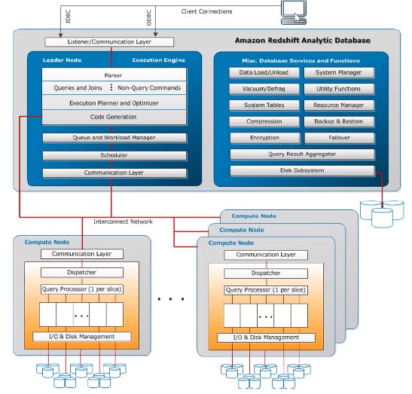

* Client Applications: ETL Tools, OLAP/BI applications
* Cluster is composed of one or more compute nodes
  + Leader Node: SQL endpoint, metadata, coordinates query execution
  + Compute Node: columnar storage of data, operate the work (MPP query, load/unload/backup/restore via S3/EMR/DynamoDB/SSH)
    - Node Slices: each slice is allocated a portion of the node’s memory and disk space, where it processes a portion of the workload assigned to the node.
* Cluster Sizing
* The amount of data you import into Amazon Redshift
* The complexity of the queries and operations that you run in the database
* The needs of downstream systems that depend on the results from those queries and operations

Choosing the Best Distribution Style

1. Distribute the fact table and one dimension table on their common columns ( i.e Dim – Primary Key and Fact – Foreign Key)
2. Choose the largest dimension based on the size of the filtered dataset.
3. Choose a column with high cardinality in the filtered result set
4. Change some dimension tables to use ALL distribution

Choosing the Best Sort Key

1. If recent data is queried most frequently, specify the timestamp column as the leading column for the sort key
2. If you do frequent range filtering or equality filtering on one column, specify that column as the sort key.
3. If you frequently join a table, specify the join column as both the sort key and the distribution key.

* Performance
  + Massively Parallel Processing (MPP)
    - Cross all compute nodes processing
    - DISTSTYLE: AUTO, EVEN, KEY(DISTKEY), ALL
      * AUTO: optimal distribution style based on the size of the table data e.g. ALL->EVEN
      * EVEN: a table does not participate in joins
      * KEY: the rows are distributed according to the values in one column e.g. joining key
      * ALL: distribute to every node
    - Loading data files: compression (e.g. gzip, lzop,bzip2), primary key (optimizer unique) and manifest files (JSON format to load exactly you want)
  + Columnar data storage
    - organizes data by column
    - rapidly filter out a large subset of data blocks with sort key
  + Data compression
    - load data with COPY command to apply automatic compression.
    - perform a compression analysis without loading data or changing the compression on a table with ANALYZE COMPRESSION

### **Cluster**

* Set of nodes – One leader node + One or more compute nodes
  + Dense storage (DS) node types are storage optimized. The dense compute (DC) node types are compute optimized.
* One database and one superuser
* Manage cluster: modify, resize, delete and reboot
* Enhanced VPC Routing
  + Force all COPY and UNLOAD traffic between cluster and data repository through VPC
  + All standard VPC features
  + Use VPC flow logs to monitor COPY and UNLOAD traffic
* Parameter group: apply all databases in the cluster
  + Use workload management (WLM) to define the number of query queues that are available, and how queries are routed to those queues for processing. WLM is part of parameter group configuration
* Snapshots: point-in-time backups of a cluster
  + Automated and manual. Redshift stores these snapshots internally in S3 by using an encrypted Secure Sockets Layer (SSL) connection
  + Automatically takes incremental snapshots that track changes to the cluster since the previous automated snapshot
  + A snapshot schedule is a set of schedule rules
  + Exclude tables from snapshots: create a no-backup table, include the BACKUP NO parameter
  + Auto copy snapshots from the source region to the destination region:  
    If you want to copy snapshots for AWS KMS-encrypted clusters to another region, you must create a grant for Redshift to use AWS KMS customer master key (CMK) in the destination region. Then you must select that grant when you enable copying of snapshots in the source region
  + Sharing snapshots: share an existing manual snapshot with other AWS customer accounts by authorizing access to the snapshot
* Monitor cluster performance: CloudWatch metrics and Query/Load performance data
* Events: Redshift tracks events and retains information about them for a period of several weeks in your AWS account
* Redshift logs: connections (connection log) and user activities (user log and user activity log) in the database
* Sizing of Redshift Clusters:

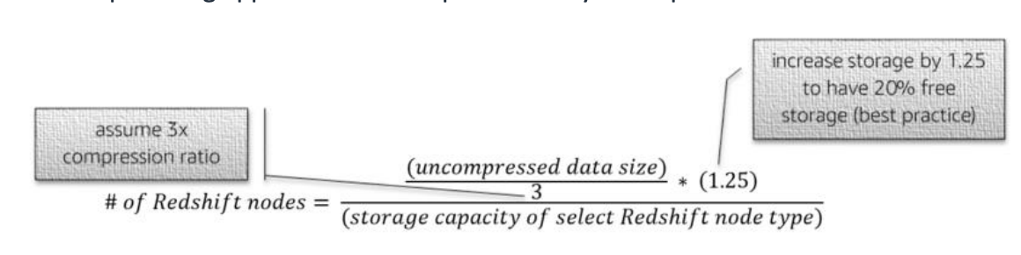

Example: 100TB DWH with a assume 3x compression ratio and ds2.xlarge node type which has 2TB of storage capacity.

* For tables created using the KEY or EVEN distribution style:  
  Minimum table size = block_size (1 MB) * (number_of_user_columns + 3 system columns) * number_of_populated_slices * number_of_table_segments.
* For tables created using the ALL distribution style:  
  Minimum table size = block_size (1 MB) * (number_of_user_columns + 3 system columns) * number_of_cluster_nodes * number_of_table_segments.

***number_of_table_segments*** is one of three values that represent the number of table segments to allocate for Amazon Redshift tables:

0: A table has never been loaded; allocate disk space for zero table segments.

1: A table without a sort key has been loaded one or more times.

2: A table with a sort key has been loaded one or more times

### **Security**

* Cluster management: IAM user, role and policy
* Cluster connectivity: EC2 or VPC Security
* Database access
  + Permission on database objects: CREATE USER, CREATE GROUP, GRANT, REVOKE
  + Database encryption: KMS, HSM
* Data In Transit
  + SQL clients to the cluster: SSL
  + Load data file: server (SSE-S3) or client-side encryption
  + COPY/UNLOAD/Backup/Restore: Hardware accelerated SSL

### **Redshift Spectrum**

A data lake is a centralized repository that allows you to store all your structured and unstructured data at any scale. AWS uses S3 to store data in any format, securely, and at a massive scale. However, this creates a “Dark Data” problem – most generated data is unavailable for analysis. To solve this Dark Data issue, AWS introduced Redshift Spectrum which is an extra layer between data warehouse Redshift clusters and the data lake in S3.

Redshift Spectrum Data Catalog Access

## **Key Features**

Redshift Spectrum has the following key features:

* A group of managed nodes in the private VPC
* Independence of the Redshift cluster and availability to any Redshift clusters that are Spectrum-enabled
* A single query on open file formats in S3 and data in Redshift without any ETL
* Fully managed and priced on a per query basis to provide higher performance and lower cost

## **Life of Query**

There are three key components to run a query with Redshift Spectrum:

* **External data catalog** contains the schema definitions for the data to access in S3. It’s a central metadata repository for the data assets. The options for external data catalog are AWS Athena (default), AWS Glue, or Apache Hive metastore (either from your own Hadoop ecosystem or from AWS EMR.)
* **External Schema** contains your tables.
* **External tables** allow you to run queries between S3 and Redshift local tables. The external tables are read-only.

Here is the life of the query on Redshift Spectrum:

1. A query is optimized and compiled at the leader node. Determine what gets run locally and what goes to Amazon Redshift Spectrum.
2. The query plan is sent to all compute nodes.
3. Compute nodes obtain partition info from the Data Catalog; dynamically prune partitions.
4. Each Compute node issues multiple requests to the Redshift Spectrum layer.
5. Amazon Redshift Spectrum nodes scan your S3 data.
6. Amazon Redshift Spectrum projects, filters, and aggregates.
7. Final aggregations and joins with local Amazon Redshift tables done in the cluster.
8. The result is sent back to the client.

**Data Migration Services (DMS)**

STEP BY STEP MIGRATION of ORACLE To REDSHIFT

* [Step 1: Launch the RDS Instances in a VPC by Using the CloudFormation Template](https://docs.aws.amazon.com/dms/latest/sbs/CHAP_RDSOracle2Redshift.Steps.LaunchRDSwCloudFormation.html)
* [Step 2: Install the SQL Tools and AWS Schema Conversion Tool on Your Local Computer](https://docs.aws.amazon.com/dms/latest/sbs/CHAP_RDSOracle2Redshift.Steps.InstallSCT.html)
* [Step 3: Test Connectivity to the Oracle DB Instance and Create the Sample Schema](https://docs.aws.amazon.com/dms/latest/sbs/CHAP_RDSOracle2Redshift.Steps.ConnectOracle.html)
* [Step 4: Test the Connectivity to the Amazon Redshift Database](https://docs.aws.amazon.com/dms/latest/sbs/CHAP_RDSOracle2Redshift.Steps.ConnectRedshift.html)
* [Step 5: Use AWS SCT to Convert the Oracle Schema to Amazon Redshift](https://docs.aws.amazon.com/dms/latest/sbs/CHAP_RDSOracle2Redshift.Steps.ConvertSchema.html)
* [Step 6: Validate the Schema Conversion](https://docs.aws.amazon.com/dms/latest/sbs/CHAP_RDSOracle2Redshift.Steps.ValidateSchemaConversion.html)
* [Step 7: Create an AWS DMS Replication Instance](https://docs.aws.amazon.com/dms/latest/sbs/CHAP_RDSOracle2Redshift.Steps.CreateReplicationInstance.html)
* [Step 8: Create AWS DMS Source and Target Endpoints](https://docs.aws.amazon.com/dms/latest/sbs/CHAP_RDSOracle2Redshift.Steps.CreateSourceTargetEndpoints.html)
* [Step 9: Create and Run Your AWS DMS Migration Task](https://docs.aws.amazon.com/dms/latest/sbs/CHAP_RDSOracle2Redshift.Steps.CreateMigrationTask.html)
* [Step 10: Verify That Your Data Migration Completed Successfully](https://docs.aws.amazon.com/dms/latest/sbs/CHAP_RDSOracle2Redshift.Steps.VerifyDataMigration.html)
* [Step 11: Delete Walkthrough Resources](https://docs.aws.amazon.com/dms/latest/sbs/CHAP_RDSOracle2Redshift.Steps.DeleteResources.html)
* <https://d1.awsstatic.com/whitepapers/strategies-for-migrating-oracle-database-to-aws.pdf?trk=wp_card>
* [Migrating Applications to AWS](https://d1.awsstatic.com/whitepapers/Migration/migrating-applications-to-aws.pdf?trk=wp_card)
* <https://aws.amazon.com/getting-started/projects/migrate-oracle-to-amazon-redshift/>
* <https://aws.amazon.com/blogs/database/how-to-migrate-your-oracle-data-warehouse-to-amazon-redshift-using-aws-sct-and-aws-dms/>
* <https://aws.amazon.com/blogs/database/aws-dms-now-supports-native-cdc-support/>
* <https://aws.amazon.com/blogs/database/the-database-migration-playbook-has-landed/>
* <https://aws.amazon.com/blogs/big-data/how-to-migrate-from-ibm-netezza-to-amazon-redshift-with-no-downtime/>

**DYNAMODB**

* <https://aws.amazon.com/blogs/big-data/scaling-writes-on-amazon-dynamodb-tables-with-global-secondary-indexes/>
* <https://aws.amazon.com/blogs/database/choosing-the-right-dynamodb-partition-key/>
* <https://docs.aws.amazon.com/amazondynamodb/latest/developerguide/GlobalTables.html>
* <https://docs.aws.amazon.com/amazondynamodb/latest/developerguide/SecondaryIndexes.html>
* <https://docs.aws.amazon.com/amazondynamodb/latest/developerguide/bp-indexes.html>
* <https://docs.aws.amazon.com/streams/latest/dev/kinesis-record-processor-ddb.html>
* [Capturing Table Activity with DynamoDB Streams](https://docs.aws.amazon.com/amazondynamodb/latest/developerguide/Streams.html)
* <https://aws.amazon.com/blogs/database/choosing-the-right-dynamodb-partition-key/>
* <https://docs.aws.amazon.com/amazondynamodb/latest/developerguide/best-practices.html>
* <https://d1.awsstatic.com/whitepapers/AWS_Comparing_the_Use_of_DynamoDB_and_HBase_for_NoSQL.pdf?trk=wp_card>
* <https://medium.com/@zaccharles/calculating-a-dynamodb-items-size-and-consumed-capacity-d1728942eb7c>

## **AWS DynamoDB**

### **Features**

* Fully managed NoSQL database service:
  + On-demand capacity mode
  + Built-in support for ACID transactions
  + On-demand backups and point-in-time recovery
  + Encryption at rest
  + Supports both key-value and document data models
* Basic concepts
  + Tables, items, attributes
  + Primary key: partition key (hash attribute) or partition key with sort key (range attribute)
  + Read consistency: Eventually consistent reads (Default) and strongly consistent reads
  + Data types: Scalar Types(number, string, binary, Boolean, and null), Document Types(list and map), Set Types(string set, number set, and binary set)
  + Secondary index: Global secondary index( any two attributes from its table), Local secondary index (the same partition with a different sort key during table creating time)
* Read/write capacity modes for each table: on-demand and provisioned (auto-scaling)
* Throughput capacity: RCU (Read Capacity Unit) = 1 strongly consistent or 2 eventually consistent reads with 4KB per item/second, WRU (Write Capacity Unit) = 1KB per item/second. Exceeded RCU or WCU of a table or one or more global secondary indexes will receive ProvisionedThroughputExceededException
* Manage throughput capacity: burst capacity (handle usage spikes) and adaptive capacity (continue reading/writing to hot partitions)
* Total number of partition = ceiling (max (capacity, size)). Capacity = total RCU/3000 + total WCU/10000. Size = total size/10GB
* Global table: replicate data automatically across your choice of the AWS regions and automatically scale capacity to accommodate your workloads
* Time to Live(TTL): the background job to delete items based on the attribute field (epoch time value) expiration
* DynamoDB Streams: provides a time-ordered sequence of item-level changes in any DynamoDB table. The changes are de-duplicated and stored for 24 hours. Trigger AWS lambda function
* DynamoDB Accelerator (DAX): in-memory cache reduces the response times of eventually-consistent read workloads by an order of magnitude, from single-digit milliseconds to microseconds

### **Security**

* DynamoDB encryption at rest encrypts your data using 256-bit Advanced Encryption Standard (AES-256), which helps secure your data from unauthorized access to the underlying storage.
* Encryption at rest integrates with AWS Key Management Service (AWS KMS) for managing the encryption key that is used to encrypt your tables. When creating a new table, you can choose one of the following customer master keys (CMK) to encrypt your table:
  + AWS owned CMK – Default encryption type. The key is owned by DynamoDB (no additional charge).
  + AWS managed CMK – The key is stored in your account and is managed by AWS KMS (AWS KMS charges apply). The AWS managed CMK provides these additional features:
* You can view the CMK and its key policy. (You cannot change the key policy.)
* You can audit the encryption and decryption of your DynamoDB table by examining the DynamoDB API calls to AWS KMS using AWS CloudTrail.
* VPC endpoint is provided through the gateway
* DynamoDB streams don’t support encryption
* Access to tables/API/DAX using IAM

## **DynamoDB Accelerator (AWS DAX)**

The main purpose of Amazon DynamoDB Accelerator (AWS DAX) is in-memory cache. DAX manages cache invalidation, data population, or cluster management. So it can deliver up to a 10x performance improvement – from milliseconds to microseconds – even at millions of requests per second.

## **AWS DAX Architecture Overview**

Amazon DynamoDB Accelerator (DAX) is a fully managed, highly available, in-memory cache for DynamoDB. Please review the architecture diagram from AWS:

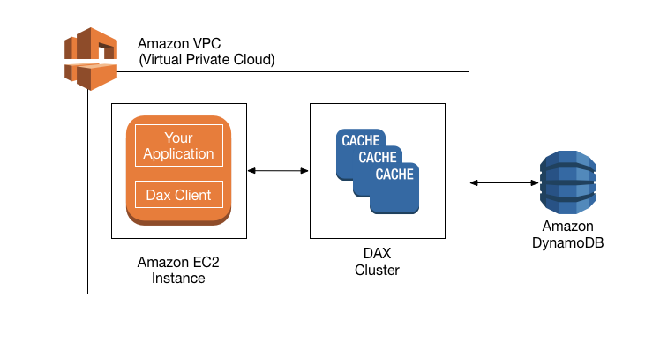

From the diagram, we can see DAX, applications and DAX client are in the same [Virtual Private Cloud (VPC)](http://www.itcheerup.net/2018/04/aws-virtual-private-cloud/)environment. So DAX  is designed to run within a VPC in order to utilize VPC’s subnets, routing tables, network gateways, and security settings. A DAX cluster consists of one or more nodes. Each node runs its own instance of the DAX caching software. One of the nodes serves as the primary node for the cluster. Additional nodes if present serves as the read replicas. At runtime, the DAX client directs all of your application’s DynamoDB API requests to the DAX cluster. If DAX can process one of these API requests directly, it does so; otherwise, it passes the request through to DynamoDB. Finally, the DAX cluster returns the results to your application.

## **Types of Caches in AWS DAX**

There are two types of caches in AWS DAX:

* Item cache: DAX maintains an *item cache* to store the results from GetItem and BatchGetItem operations. The items in the cache represent eventually consistent data from DynamoDB and are stored by their primary key values.
* Query cache:  DAX maintains a query cache to store the results from Query and Scan operations. The items in this cache represent result sets from queries and scans on DynamoDB tables. These result sets are stored by their parameter values.

## **AWS DAX Flow Diagram**

There are two categories of these APIs. Read APIs include GetItem, BatchGetItem, Query, and Scan. Modify APIs include PutItem, UpdateItem, DeleteItem, and BatchWriteItem

Let’s take a look at the flow diagram on DAX to read/write operations:

The left side is read through. When your application requests the read operation, there is no cache for the first time. DAX creates a cache and reads data from DynamoDB. Then in the second time, the application will hit the cache and return the item back to the application. The right side is the example of write through. The application writes data directly into DynamoDB. DAX sync the data in the cache. Then next time, the application will hit the cache to get the results. A picture containing text

## **Conclusion**

AWS DAX provides a way to do in-memory cache. DAX reduces the response times of eventually-consistent read workloads from single-digit milliseconds to microseconds. DAX does increase throughput and save cost by reducing the need to over-provision read capacity units. However, If your applications that require strongly consistent reads or write-intensive, then you should not use DAX.

**VISUALIZATION**

* ML Insights for Quicksights – Anomaly Detection (Random Cut Forest), Forecasting, Natural language narratives and summaries.
* SPICE (Super-fast in-memory calculation engine).
* Pricing - $18/user/month (authors) $5/user/month.
* Share dashboards with external users mostly viewers.
* <https://aws.amazon.com/blogs/big-data/analyze-realtime-data-from-amazon-kinesis-streams-using-zeppelin-and-spark-streaming/>
* <https://aws.amazon.com/blogs/big-data/running-jupyter-notebook-and-jupyterhub-on-amazon-emr/>
* [Visualize AWS Cloudtrail Logs Using AWS Glue and Amazon QuickSight](https://aws.amazon.com/blogs/big-data/streamline-aws-cloudtrail-log-visualization-using-aws-glue-and-amazon-quicksight/)
* <https://aws.amazon.com/blogs/machine-learning/build-a-social-media-dashboard-using-machine-learning-and-bi-services/>
* [QuickSight FAQ](https://aws.amazon.com/quicksight/resources/faqs/)

**SECURITY**

* <https://docs.aws.amazon.com/redshift/latest/mgmt/working-with-db-encryption.html>
* <https://hadoop.apache.org/docs/r2.7.1/hadoop-mapreduce-client/hadoop-mapreduce-client-core/EncryptedShuffle.html>
* <https://aws.amazon.com/blogs/big-data/best-practices-for-securing-amazon-emr/>

**ELASTIC SEARCH**

* Amazon ElasticCache is a web service that makes it easy to deploy and run Memcached or Redis protocol-compliant server nodes in the cloud.
* Improves the performance of web applications by allowing you to retrieve information from a fast, managed, in-memory system. Not only improves load and response times to user actions and queries, but also reduce costs.
* **ElasticCache for Memcached** – For Persistent data stores (AWS RDS, DynamoDB) ,Dynamically generated web pages (Nginx) or transient data sessions providing extremely low latency for high performance applications. Also used in conjunction with EC2 + EMR.
* Maximum – 100 nodes per region. Largest ElasticCache node size: cache.r5.24xlarge = 635.61 GB
* **ElasticCache for Redis –** Engine Option, Managed service, Elasticcache for Redis node supports the Redis protocol and has its own DNS name and port.
* It may take on a primary or a read replica role. A primary node can be replicated to multiple read replica nodes.
* An ElasticCache for Redis replication group consists of a primary and up to 5 read replicas.
* It can also be used a primary in-memory key-value data store, providing fast sub millisecond data performance, high availability and scalability up to 250 nodes and 250 shards, giving up to 170 Tb of in-memory data.

When to choose Memcached/Redis?

* **Memcached** --Simplest Model Run large nodes with multiple cores/threads. Cache Objects such as Databases, Ngnix. High-performance, distributed memory object caching system intended for use in speeding up dynamic web applications.
* **Redis** – Redis Streams, Automatic failover, pub/sub systems, message broker, backup, restore, multiple databases, complex datatypes, geospatial indexing, partition data across 2 – 90 node groups, No scale up to larger node types.
* ***Example for Redis*** Gaming Leaderboards (Redis Sorted Sets), Messaging (Pub/Sub System), Media Streaming Service, Session Store, Job Queue, Machine learning (Real-time Model Scoring)
* [Performance at Scale with Amazon ElastiCache](https://d1.awsstatic.com/whitepapers/performance-at-scale-with-amazon-elasticache.pdf?trk=wp_card)
* <https://aws.amazon.com/blogs/database/latency-reduction-of-hybrid-architectures-with-amazon-elasticache/>
* <https://aws.amazon.com/blogs/mobile/integrating-aws-appsync-neptune-elasticache/>
* <https://docs.aws.amazon.com/AmazonElastiCache/latest/mem-ug/Strategies.html>
* https://aws.amazon.com/blogs/database/indexing-metadata-in-amazon-elasticsearch-service- using-aws-lambda-and-python/

WHITEPAPERS

* [Comparing the Use of Amazon DynamoDB and Apache HBase for NoSQL](https://d+awsstatic.com/whitepapers/AWS_Comparing_the_Use_of_DynamoDB_and_HBase_for_NoSQL.pdf)
* [Lambda Architecture for Batch and Stream Processing](https://d+awsstatic.com/whitepapers/lambda-architecure-on-for-batch-aws.pdf)
* [Enterprise Data Warehousing on AWS](https://d+awsstatic.com/whitepapers/enterprise-data-warehousing-on-aws.pdf)
* [Glacier Expedited, Standard, and Bulk Retrieval Types](https://aws.amazon.com/about-aws/whats-new/2016/11/access-your-amazon-glacier-data-in-minutes-with-new-retrieval-options/)
* [Server-Side Encryption for Kinesis Data Streams](https://docs.aws.amazon.com/streams/latest/dev/what-is-sse.html)
* [Visualize AWS Cloudtrail Logs Using AWS Glue and Amazon QuickSight](https://aws.amazon.com/blogs/big-data/streamline-aws-cloudtrail-log-visualization-using-aws-glue-and-amazon-quicksight/)
* [Analyze Apache Parquet optimized data using Kinesis Data Firehose, Athena, and Redshift](https://aws.amazon.com/blogs/big-data/analyzing-apache-parquet-optimized-data-using-amazon-kinesis-data-firehose-amazon-athena-and-amazon-redshift/)
* [Building a Binary Classification Model with Machine Learning and Redshift](https://aws.amazon.com/blogs/big-data/building-a-binary-classification-model-with-amazon-machine-learning-and-amazon-redshift/)
* [AWS IoT Authentication](https://docs.aws.amazon.com/iot/latest/developerguide/iot-authentication.html)
* [Use Business Intelligence Tools with EMR](https://docs.aws.amazon.com/emr/latest/ManagementGuide/emr-bi-tools.html)
* [JOIN Redshift AND RDS PostgreSQL WITH dblink](https://aws.amazon.com/blogs/big-data/join-amazon-redshift-and-amazon-rds-postgresql-with-dblink/)

Big Data Analytics Options on AWS (READ, very good for Case Studies)

Building Big Data Storage Solutions (Data Lakes) for Maximum Flexibility

Comparing the Use of Amazon DynamoDB and Apache HBase for NoSQL (November 2018)

Migrating to Apache HBase on Amazon S3 on Amazon EMR (October 2018)

Best Practices for Amazon EMR (August 2013) (VERY USEFUL)

----------------------------------------------FROM BLOGS------------------------------------------------

-- Querying Amazon Kinesis Streams directly with SQL and Spark Streaming (Sort of obsolete since queries can be run using Kinesis Analytics instead of Hive)

-- Optimize Spark Streaming to efficiently process Amazon Kinesis Streams

-- Analyze Real Time data from Amazon Kinesis Streams using Zeppelin and Spark Streaming

-- Powering Amazon Redshift Analytics with Apache Spark and Amazon Machine Learning (Fantastic)

-- Using Spark SQL for ETL (READ, very good)

-- Implementing Efficient and Reliable Producers with the Amazon Kinesis Producer Library

-- Amazon Kinesis Firehose Data Transformation with AWS Lambda

-- Secure Amazon EMR with Encryption

-- Building a Near Real-Time Discovery Platform with AWS

-- Top 8 Best Practices for High-Performance ETL Processing Using Amazon Redshift

-- Scaling Writes on Amazon DynamoDB Tables with Global Secondary Indexes

-- Combine NoSQL and Massively Parallel Analytics Using Apache HBase and Apache Hive on Amazon EMR

-- Choosing the Right DynamoDB Partition Key

-- Strategies for Reducing Your Amazon EMR Costs (a little Old but useful)

-- Best practices for resizing and automatic scaling in Amazon EMR

**AWS Machine Learning / AWS SageMaker**

* <https://d1.awsstatic.com/whitepapers/aws-managing-ml-projects.pdf?trk=wp_card>
* <https://aws.amazon.com/blogs/machine-learning/bring-your-own-deep-learning-framework-to-amazon-sagemaker-with-model-server-for-apache-mxnet/>
* <https://aws.amazon.com/blogs/machine-learning/adding-a-data-labeling-workflow-for-named-entity-recognition-with-amazon-sagemaker-ground-truth/>
* <https://aws.amazon.com/blogs/machine-learning/creating-custom-labeling-jobs-with-aws-lambda-and-amazon-sagemaker-ground-truth/>
* <https://aws.amazon.com/blogs/machine-learning/exploring-data-warehouse-tables-with-machine-learning-and-amazon-sagemaker-notebooks/>
* <https://aws.amazon.com/blogs/machine-learning/build-end-to-end-machine-learning-workflows-with-amazon-sagemaker-and-apache-airflow/>
* <https://aws.amazon.com/blogs/machine-learning/build-a-serverless-anomaly-detection-tool-using-java-and-the-amazon-sagemaker-random-cut-forest-algorithm/>
* <https://aws.amazon.com/blogs/machine-learning/bring-your-own-hyperparameter-optimization-algorithm-on-amazon-sagemaker/>
* https://aws.amazon.com/blogs/machine-learning/automated-and-continuous-deployment-of-amazon-sagemaker-models-with-aws-step-functions/
* <https://aws.amazon.com/blogs/machine-learning/anomaly-detection-on-amazon-dynamodb-streams-using-the-amazon-sagemaker-random-cut-forest-algorithm/>
* <https://aws.amazon.com/blogs/machine-learning/your-guide-to-ai-and-machine-learning-at-reinvent-2018/>
* <https://aws.amazon.com/blogs/machine-learning/access-amazon-s3-data-managed-by-aws-glue-data-catalog-from-amazon-sagemaker-notebooks/>
* Good Data – Large Datasets, Precise attribute types, feature rich, complete fields, consistent values, solid distribution, fair sampling
* Bad data – Small datasets, useless attributes, missing values, null fields, inconsistent values, imbalanced datasets, biased sampling, skewed distributions of biased data and outcomes.
* GroundTruth -factual data that has been observed or measured.
* Amazon Sagemaker Ground Truth and AWS Mechanical Truck.
* S3 – Go to place for store ML data for direct integration of AWS Services.

## **Machine Learning (ML) Services**

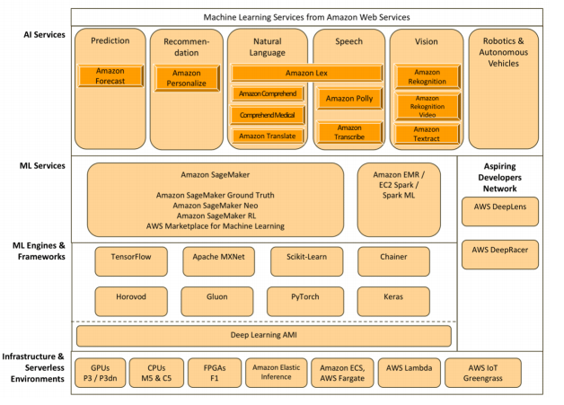

### **AI Services**

* Amazon Comprehend: natural language processing (NLP) service that uses machine learning to find insights and relationships in a text
* Amazon Lex: advanced deep learning functionalities of automatic speech recognition (ASR) for converting speech to text, and natural language understanding (NLU) to recognize the intent of the text, to enable you to build applications with highly engaging user experiences and lifelike conversational interactions e.g. chatbots
* Amazon Polly: turns text into lifelike speech
* Amazon Rekognition: image and video analysis
* Amazon Transcribe: automatic speech recognition (ASR) service that makes it easy for developers to add speech-to-text capability to their applications
* Amazon Textract: automatically extracts text and data from scanned documents and forms
* Amazon Translate: neural machine translation service that delivers fast, high-quality, and affordable language translation
* Amazon Forecast: delivers highly accurate forecasts, and is based on the same technology used at Amazon.com
* Amazon Personalize: create the individualized product and content recommendations for customers using their applications
* Amazon Comprehend Medical: natural language processing service that extracts relevant medical information from unstructured text using advanced machine learning models

### **AWS Machine Learning (ML)**

* Datasources contain metadata associated with data inputs to ML
* ML Models generate predictions using the patterns extracted from the input data
* Evaluations measure the quality of ML models
* Batch Predictions asynchronously generate predictions for multiple input data observations
* Real-time Predictions synchronously generate predictions for individual data observations
* Datasources
  + Pre-split the data – You can split the data into two data input locations, before uploading them to Amazon Simple Storage Service (Amazon S3) and creating two separate datasources with them.
  + Amazon ML sequential split – You can tell Amazon ML to split your data sequentially when creating the training and evaluation datasources.
  + Amazon ML random split – You can tell Amazon ML to split your data using a seeded random method when creating the training and evaluation datasources.
* ML Models
  + Supervised learning
    - Regression: predict a numeric value
    - Multiclass: predict values that belong to a limited, pre-defined set of permissible values.
    - Binary: predict values that can only have one of two states, such as true or false
  + Unsupervised learning – not support

### **SageMaker**

* Build, train, and deploy machine learning models quickly.  Take away the limitation of 100GB training data from AWS machine learning
* SageMaker provides fully-managed and pre-built Jupyter notebooks to address common use cases
* SageMaker supports RL in multiple frameworks, including TensorFlow and MXNet, as well as custom-developed frameworks
* GPU accelerated deep learning, scaling effectively unlimited hyperparameter tuning jobs. P2, P3 and G3 instance type for deep learning

**VISUALIZATION**

<https://aws.amazon.com/blogs/big-data/streamline-aws-cloudtrail-log-visualization-using-aws-glue-and-amazon-quicksight/>

## **Elasticsearch**

* Elasticsearch is a popular open-source search and analytics engine for use cases such as log analytics, real-time application monitoring, and clickstream analysis.
* AWS Elasticsearch Service domains are Elasticsearch clusters created using the AWS Elasticsearch Service console, CLI, or API.
* A collection of connected nodes is called a cluster
  + Dedicated master nodes: recommend three dedicated master nodes to performs cluster management tasks.
  + Data nodes: hold data and perform data-related operations such as CRUD, search, and aggregations.
  + ElasticSearch creates an index for each field
  + Data is stored in indexes and distributed across shards
  + Shards are primary or replica. The primary shard count can’t be changed. ElasticSearch distributes the shards to instances elastically. Primary and replica are distributed to different instances
  + Instance types: T (3.5TB, dev/QA), M (150TB, data/queries are average), I (150TB, higher request volumes/larger documents/heavy aggregation), C (150TB, high concurrency), I (1.5PB, XL storage needs)
  + (Source Data + Room to Grow) * (1 + Indexing Overhead) / Desired Shard Size = Approximate Number of Primary Shards
  + Source Data * (1 + Number of Replicas) * 1.45 = Minimum Storage Requirement
* ES domains offer encryption of data at rest, a security feature that helps prevent unauthorized access to your data. The feature uses the AWS Key Management Service (AWS KMS) to store and manage your encryption keys. If enabled, it encrypts the following aspects of a domain:
  + Indices
  + Automated snapshots
  + Elasticsearch logs
  + Swap files
  + All other data in the application directory
* The following are not encrypted when you enable encryption of data at rest, but you can take additional steps to protect them:
  + Manual snapshots
  + Slow logs and error logs
* AWS Elasticseach vs. AWS CloudSeach:
  + ES: Analytics
  + CS: search on web pages, document files, forum posts, product information. Features: Full-text search, Boolean search, Prefix searches, Range searches, Term boosting, Faceting, Highlighting, Autocomplete Suggestions

## **AWS S3**

### **Features**

* Storage classes:
  + S3 Standard – general Purpose of frequently accessed data. 99.999999999% durability and 99.99% availability across multiple AZs with 2 concurrent facility failures
  + S3 Standard-Infrequent Access (IA) – long-lived, but less frequently accessed data. Cost less than S3 standard with the same durability and availability across multiple AZs
  + S3 One Zone-Infrequent Access – support same data access as standard IA but in single AZ. Cost less than S3 Standard IA with 99.999999999% durability and 99.5% availability
  + S3 Intelligent Tiering – optimize storage costs by automatically moving data to the most cost-effective storage access tier
  + Glacier – long-term archive. Archives are stored in vaults. The vault has access policy (restrict user/account permissions) and lock policy (immutable never be changed) – 90 Days. Retrieval tin e: Min/Hours
  + Glacier Deep Archive - Data is stored across 3 or more AWS Availability Zones and can be retrieved in 12 hours or less. – 180 Days (Minimum # of days)
* Access Control Lists(ACL): allow Read and/or Write access to both the objects in the bucket and the permissions to the object
* Versioning: can only be disabled on the bucket but not removed after enabled versioning
* Lifecycle management: transition through the tiers e.g. S3 standard to IA to Glacier
* Consistency models: read after write consistency for PUTS of new objects; eventual Consistency for DELETES and PUTS of existing objects
* With S3 Select you can extract records from a single CSV, JSON or Parquet file using SQL expressions. S3 Select supports GZIP and BZIP2 compressed files and server-side encrypted files. You can use the console to extract up to 40 MB of records from source files up to 128 MB; to work with larger files or more records, use the API.
* Supports Data access auditing – IAM/Identity Information from CloudTrail Events
* Amazon Macie is a AI powered service that monitors data access activity for anomalies and deliver alerts when it detects risk of unauthorized access or inadvertent data leaks.
* S3 “Query in Place” – S3 Select, Athena, Amazon Redshift Spectrum. S3 + AWS Lambda to build serverless apps that can take advantage of in-place processing capabilities
* S3 Event Notifications (PUTs,POSTs,COPYs, DELETEs) through SNS, SQS, AWS Lambda.

### **Security**

* Encryption: SSE-S3, SSE-KMS, SSE-C, and client-side encryption
* IAM: bucket policies and user policies, ACLs, block

## **AWS SQS**

* Fully managed message queues. Supports both standard and FIFO queues
* Message size limit is 256KB
* Security
  + IAM: IAM user/role to allow usage of SQS, access policy to control over IP or control over the time the requests come in
  + SSE-KMS encrypts the body but not metadata
  + HTTPS

# Apache Hadoop Ecosystem Cheat Sheet

Apache Hadoop [3.1.1](http://hadoop.apache.org/docs/r3.1.1/) was released on the eighth of August with major changes to YARN such as GPU and FPGA scheduling/isolation on YARN,  docker container on YARN, and more expressive placement constraints in YARN. Apache Hadoop has been in development for nearly 15 years. The term “Hadoop” refers to the Hadoop ecosystem or collection of additional software packages that can be installed on top of or alongside Hadoop. Seeing as to how there are so many add-on libraries on top of Apache Hadoop, the Apache Hadoop ecosystem can be a little bit overwhelming for a person new to the term. You will be a zookeeper, surrounded and overwhelmed by such exotic animals (Pig, Hive, Phoneix, Impala) and funny names such as the Oozie, Tez, and Sqoop. Therefore, I have made this cheat sheet for you to understand the technologies in the Apache Hadoop ecosystem. Moreover, I will write some articles comparing different packages so you can easily select packages for your Apache Hadoop ecosystem.

## **What is Apache Hadoop?**

Apache [**Hadoop**](http://hadoop.apache.org/) is an open-source software framework for storing data and running applications on clusters of commodity hardware. It provides the software framework for massive storage, enormous MapReduce processing power, and the ability to handle virtually limitless concurrent tasks or jobs.

The modules of Apache Hadoop include:

* **Hadoop Common**: The common utilities that support the other Hadoop modules.
* **Hadoop Distributed File System (**[**HDFS**](http://hadoop.apache.org/docs/r3.1.1/hadoop-project-dist/hadoop-hdfs/HdfsDesign.html)**™)**: A distributed file system that provides high-throughput access to application data.
* **Hadoop**[**YARN**](http://hadoop.apache.org/docs/r3.1.1/hadoop-yarn/hadoop-yarn-site/YARN.html): A framework for job scheduling and cluster resource management.
* **Hadoop**[**MapReduce**](http://hadoop.apache.org/docs/r3.1.1/hadoop-mapreduce-client/hadoop-mapreduce-client-core/MapReduceTutorial.html): A YARN-based system for parallel processing of large data sets.

## **NoSQL Database**

* **Apache HBase:**A random, real-time read/write NoSQL database (wide column store) to access data in Hadoop. Apache HBase provides Bigtable-like capabilities on top of Hadoop and HDFS.

## **Scripting**

* **Apache Hive**: Facilitates reading, writing, and managing large datasets residing in distributed storage using SQL. A SQL-like query (Hive SQL) generates MapReduce code.
* **Apache Pig**:  A high-level language similar to Python or Bash for expressing data analysis programs. An ETL library generates MapReduce jobs just like Hive does.
* **Apache Impala**: An open source massively parallel processing (MPP) SQL query engine for data stored in a computer cluster running Apache Hadoop. Unlike **Hive**, **Impala** does not translate the queries into MapReduce jobs but executes them natively, meaning that it is faster than Hive.
* **Apache Drill**: An open-source software framework that supports data-intensive distributed applications for interactive analysis of large-scale datasets. Schema-free SQL Query Engine for Hadoop, NoSQL and Cloud Storage.
* **Apache Phoneix**: An open source, massively parallel, relational database engine supporting OLTP for Hadoop using Apache HBase as its backing store.
* **Presto**: An open source distributed SQL query engine for running interactive analytic queries against data sources of all sizes ranging from gigabytes to petabytes.

## **Data Serialization**

* **Apache Avro**: A remote procedure call and data serialization framework developed within Apache’s Hadoop project. It uses JSON for defining data types and serializes data in a compact binary format.

## **Workflows**

* **Apache Oozie**:  A workflow scheduler system that manages Apache Hadoop jobs. Oozie Workflow jobs are Directed Acyclical Graphs (DAGs) of actions. Oozie Coordinator jobs are recurrent Oozie Workflow jobs triggered by time (frequency) and data availability.
* **Apache Tez**: An application framework which allows for a complex directed-acyclic-graph (DAG) of tasks for processing data.  It is currently built atop Apache Hadoop YARN. In some cases, it is used as an alternative to Hadoop MapReduce.
* **Apache**[**Kafka**](http://www.itcheerup.net/2019/01/kafka-vs-kinesis/): Provide a unified, high-throughput, low-latency platform for handling real-time scalable pub/sub message queue data feeds.

## **Connectors**

* **Apache Flume**: A distributed, reliable, and available service for efficiently collecting, aggregating, and moving large amounts of log data.
* **Apache Sqoop**:  A tool designed for efficiently transferring bulk data (importing/exporting) between Apache Hadoop and structured datastores such as relational databases.

## **Data Processing**

* **Apache Flink**: A framework and distributed processing engine for stateful computations over unbounded and bounded data streams. Flink has been designed to run in all common cluster environments, perform computations at in-memory speed and at any scale. So Flink supports event time semantics for out-of-order events, exactly-once semantics, backpressure control, and APIs optimized for writing both streaming and batch applications.
* **Apache Spark**: A powerful open-source unified analytics engine built around speed, ease of use, and streaming analytics. Spark runs on Hadoop, Mesos, Kubernetes, standalone, or in the cloud. It has the following components:
  + Spark Core:  Dispatching, scheduling, and basic I/O functionalities
  + Spark SQL: DSL (domain-specific language)  to manipulate DataFrames. Because of its in-memory computing, the performance is even faster than **Apache Impala**.
  + Spark Streaming: Micro-batching to perform fast streaming
  + MLib: Scalable and easy machine learning library
  + GraphX: Distributes graph processing framework
* **Apache Storm**: A real-time computation system designed to handle large streams of data within Hadoop. It can do micro-batching and stateful stream processing in batches using a trident.

## **Machine Learning**

* **Apache Mahout**:  A distributed linear algebra framework and mathematically expressive Scala DSL (domain-specific language) designed to perform predictive analytics on Hadoop data.
* **Apache MXNet**: An acceleration library designed for building neural networks and other deep learning applications. MXNet automates common workflows and optimizes numerical computations.
* **Spark MLib**, **Storm SAMOA**, and **Flink ML**

## **Coordination**

* **Apache Zookeeper**:  A centralized service for maintaining configuration information, naming, providing distributed synchronization, and providing group services.

## **Management and Monitoring**

* **HCatalog**: A table storage management tool. It allows you to access Hive metastore tables within Pig, Spark SQL, and/or custom MapReduce applications.
* **Ganglia:** A scalable distributed monitoring system for high-performance computing systems such as clusters and Grids.
* **Apache Ambari**:  A web-based tool for provisioning, managing, and monitoring Apache Hadoop clusters. Allows configuration and management of a Hadoop cluster from one central web UI.
* **HUE**(**Hadoop User Experience):** An open source Analytics Workbench for browsing, querying and visualizing data on a Web UI. It is developed by the Cloudera.

## **Interactive Notebooks**

* **Apache Zeppelin**: A web-based notebook that enables data-driven, interactive data analytics and collaborative documents with SQL, Scala and more.
* **Jupyter Notebook**:  An open-source web application that you can use to create and share documents that contain live code, equations, visualizations, and narrative text.

## **Security**

* **Apache Ranger**: A framework to enable, monitor and manage comprehensive data security across the Hadoop platform.
* **KNOX Gateway**: A system that provides a single point of authentication and access for the Hadoop services in a cluster.

## **Conclusion**

In conclusion, the open-source Apache Hadoop ecosystem provides many add-on libraries to support your projects. However, it can also be challenging and time-consuming to set up the system. We will take a look at the commercial Hadoop solutions and the Hadoop on cloud options.

**AWS Data Lake Formation**

* Simplified ingest & cleansing with fine grained permissions
* AWS Glue + Blueprints + ML Transforms
* Tools that enable data engineers, security officers, data analysts to effectively use data lake
* AWS Glue

- Glue Data Catalog -> Discover Automatic crawling and Apache Hive metastore

- Develop – Serverless Engine with Spark (Python & Scala shells), Glue ETL jobs

- Glue Crawlers

- Deploy – Orchestration

* Blueprints (Discover -> Convert -> Partition -> Track -> Customize)
  + Pre-built templates to serve common ingestion use cases
  + Built Glue workflows
  + Load data incrementally and full load
  + Discover with Glue crawler and Glue data cataog
* ML Transformations (Deduplication / Record Matching)
* Data Catalog & Permissions (IAM & S3 Policies)
  + Lake formation & AWS Glue used the same data catalog
  + Existing Glue Crawlers, jobs, triggers and workflows will not change
* Lake formation authorizes access to recourses (token vending) to Redshift, Glue, EMR, Athena – Complaint services .
* Audit and Monitor in real-time with Cloud Trail APIs (Athena Querying), CloudWatch.
* <https://aws.amazon.com/blogs/security/how-to-visualize-and-refine-your-networks-security-by-adding-security-group-ids-to-your-vpc-flow-logs/#more-3559>

**Data Lake Architecture Blogs**

* <https://aws.amazon.com/blogs/database/how-to-stream-data-from-amazon-dynamodb-to-amazon-aurora-using-aws-lambda-and-amazon-kinesis-firehose/>
* <https://aws.amazon.com/blogs/big-data/our-data-lake-story-how-woot-com-built-a-serverless-data-lake-on-aws/>
* <https://aws.amazon.com/blogs/big-data/build-a-data-lake-foundation-with-aws-glue-and-amazon-s3/>